Table of contents

1. Introduction 1

1.1. Context and relevance of the research topic 1

2. Study of Convolutional Neural Networks. 3

3. Study of Two-Stage Object Detection 6

3.1. Region-Based CNN (R-CNN) 6

3.2. Fast R-CNN 9

3.3. Faster R-CNN 10

3.4. Mask R-CNN 12

3.5. Feature Pyramid Networks (FPN) 14

4. Study of One-Stage Object Detection 16

4.1. You Only Look Once (YOLO) 16

4.2. YOLOv2 18

4.3. YOLOv3 19

4.4. YOLOv4 20

4.5. YOLOv5 26

4.6. Other One-Stage Object Detectors 28

4.6.1. Single Shot Detection (SSD) 28

4.6.2. RetinaNet 28

4.6.3. EfficientDet 28

5. Evaluation Methods for Object Detection Models 29

5.1. Precision 29

5.2. Recall 29

5.3. Average Precision (AP) 30

5.4. Intersection Over Union (IoU) 30

5.5. Mean Average Precision (mAP) 31

6. Data Recollecting 32

6.1. Help Protect the Great Barrier Reef Dataset 32

6.2. FishCLEF-2015 Dataset 33

6.3. Luderick-Seagrass Dataset 33

7. Data Preprocessing 34

# 1. Introduction

## 1.1. Context and relevance of the research topic

Deep learning is revolutionizing AI with the increase in computational power with graphic cards and the increased interest from researchers, whose research on the topic is competitive and fast, having solutions become obsolete in a year or two in favor of new ones. Deep Learning solutions can range from simple image classification to natural language processing, motion planning, price forecasting and more. The world is becoming more aware of the advantages of using AI and it is sadly not only used for good, as lots of companies use it for morally dubious purposes such as attacking our privacy by tracking every interest of a person online and changing their habits and way of thinking for profit.

Object detection is one of the most researched topics in Deep Learning and is the focus of this project. It is also a great example of the speed at which research is going, as one of the most ancient solutions, Fast R-CNN which released in 2014, is heavily obsolete as of 2022 and it has been since 2015. Object detection focuses on finding objects on an image by returning a box that encapsulates each of them, called bounding boxes, and the class of the object, which could be a dog or a cat, for example.

Detection can be used by autonomous cars to avoid obstacles, satellites to find anomalies, video cameras to detect faces and much more. One of the fields where it is heavily used is in the military, using it on drones and missiles to detect their target, such uses of this technology do not interest me, and I wanted to find one morally fulfilling field to apply AI.

I chose to center the task around underwater species detection inspired by an online competition with the objective of detecting invasive species of starfish, the Crown of Thorns Starfish, which threatens the coral in the great barrier reef in Australia. I thought that being able to detect invasive underwater species in real time video could be useful for the purpose of finding them using robots to identify the areas where action could be taken against those species. The main purpose of this work is doing a study of object detection models since their inception, centered around their performance on real-time detection on videos, and training and evaluating detectors on a public underwater fish detection dataset.

## 1.2 Objectives

The main purpose of this project is the **implementation of a real-time object detection model on videos of underwater species**. Optional objectives related to real-time detection are added in the project, such as carrying out instance segmentation, where each pixel of the detected animal is painted and getting extra information from detections, like using object tracking that could help count the total number of fishes in a video sequence. The last optional objective is to create my own detection dataset from public underwater videos. In order to achieve this goal, the following objectives were to be completed:

* Design an object detection and classification model for underwater species.
  + Evaluate the data and make a good training and validation Split
  + Preprocess the data before training the model.
  + Find the Deep Learning model that better suits the problem
  + Evaluate the model.
  + Make sure that the model is fast enough to detect objects in real time during a video.
* (Optional) Design a Segmentation model that paints each pixel of a detected object
* (Optional) Extract extra information from detections.
* (Optional) Create my own detection dataset from public underwater videos.

# 2. Study of Convolutional Neural Networks.

**Image classification** is a common topic when learning about deep learning and computer vision. It consists of using one image as input to a neural network and receiving a prediction of its class. Is the image a dog or a cat? A type of neural network called **Convolutional Neural Network** (**CNN**), is usually used to solve those kinds of problems as represented in Figure 1.

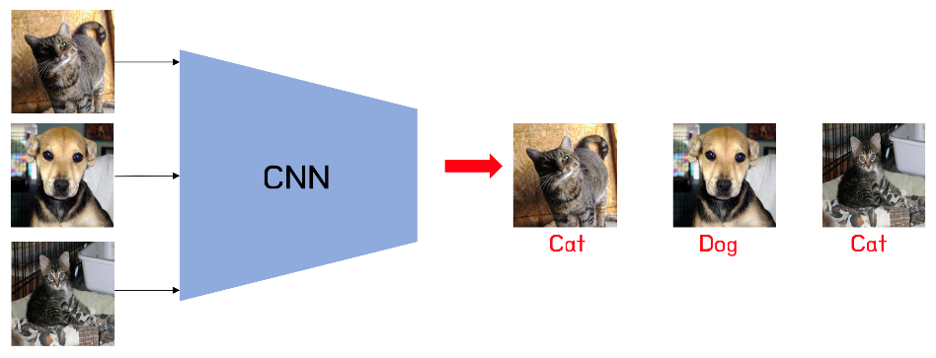

Figure 1: CNNs can be trained to predict classes from given images. Source: Google Images

A **CNN** is a neural network that includes **convolutional layers**, which consist of a list of a set number of kernels with a given shape (n x n) that slide through the image with a step of a given number of pixels called “**stride**”, computing for each step the dot product of the n x n values of the kernel with the corresponding pixel values of the image in that step. Each kernel is passed through all the images of the input, which can be three for the first layer if the input is an RGB image, having three color channels as shown in Figure 2, or could be the number of kernels in the previous convolutional layer.

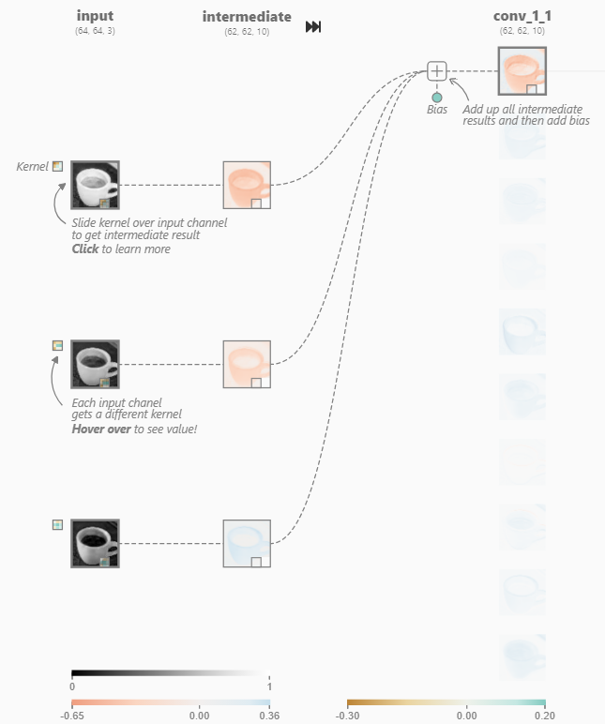

Figure 2: The input layer and first convolutional layer from a CNN (left) and a close view of one of its kernels (right). Source: [CNN explainer website](https://poloclub.github.io/cnn-explainer/)

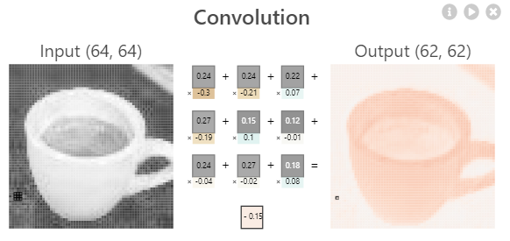

The values of each of the n x n values in each kernel and the biases are the **trainable parameters, also called weights,** of the neural network. Weights, which are initially initialized randomly, are “trained” by optimizing (or minimizing) the final **loss function** of the network, which computes the “distance” between the predicted output and the truth (ground truth). There are different loss functions aimed at different kind of problems. If the network must predict a class, a **Categorical Crossentropy** loss is commonly used, which is defined as follows:

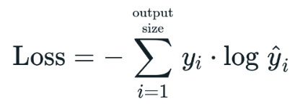

Where y equals 1 if the true label of that example is the class *i* and 0 if not. **ŷ**i stands for the output probability of the example being the class *i* according to the network. This formula increases if the true class has a low prediction probability, as it results in the negated log of that probability, which increases as the probability is closer to 0.

There are different **optimization algorithms**, such as **Stochastic Gradient Descent (SGD)** or **Adam**, used to minimize the loss function (see Figure 3) using partial derivatives in respect to each weight by applying the chain rule from the loss function back to that weight, by multiplying the partial derivatives of all the functions in the way. That is why the process of optimizing the network is called “**backpropagation”.** After computing the partial derivatives, each weight is updated by multiplying a set parameter known as **Learning Rate,** usually lower than 1, to the result of its partial derivatives (depends on the optimization algorithm) and subtracting that number from the original weight.

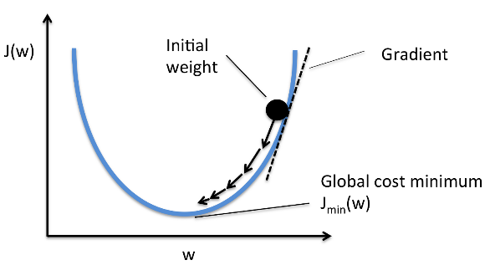

Figure 3: Example of a simple case of gradient descent with one weight. The partial derivative (Gradient) of the final function J(w) with respect to w is positive if J(w) increases as w does, or negative if it decreases when w increases. To minimize J(w), the derivative multiplied by a learning rate is subtracted from w, ensuring that the next value of J(w) will be closer to the minimum, as a positive derivative indicates that w should decrease and a negative one indicates it should increase.

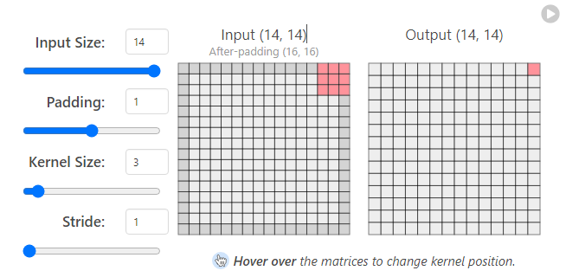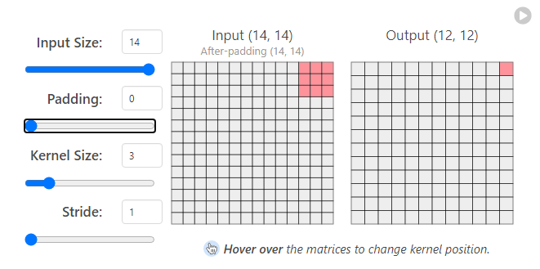The final output of each kernel is the sum of the results for all the inputs plus a bias, which then is passed through a non-linear activation function, such as **ReLU** = max (input, 0). The output shape can be different from the input depending on the kernel size and stride. For example, a 3x3 kernel going through a 14x14 image outputs a 12x12 image, as the right side of the kernel reaches the end of the image in 12 steps, and the bottom of the kernel reaches the bottom of the image in 12 steps as well. Reshaping can be avoided with the use of **padding**, like adding 0 to each border of the image, thus becoming a 16x16 image as shown in Figure 4. Output sizes can also be higher than the original depending on the stride and padding.

Figure 4: 3x3 kernels can generate an output of the same size as the original image if a padding of 1 pixel is used.

CNNs include other layers as well, typically the **Pooling layers**, whose main function is to reduce the output size of the previous layer. For example, **MaxPooling** layers use a n x n kernel that slides through the input image, like a convolutional kernel, and the output is simply the maximum value of the pixel in that region for each step, as shown in Figure 5.

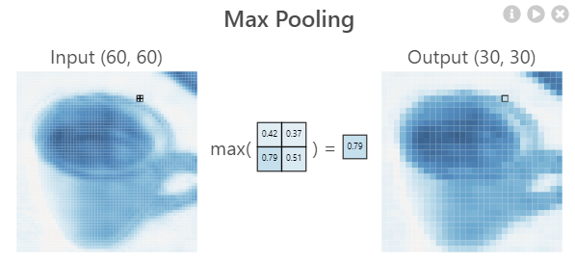

Figure 5: Max Pooling in detail.

The final output of a layer in a CNN is a concatenation of all the kernel outputs and is called **feature map,** which is a 3-dimensional matrix. After all the convolutional and pooling layers, the last feature map is flattened and becomes a 1D array including all the values of the feature map. For example, if the last layer is a Convolutional layer of 10 kernels, each generating a 5x5 output, the output would be a **5x5x10 feature map** and the flattened output would be an array of 5x5x10 = **250 values**. CNNs can also have fully connected layers at the top (end) after the flatten layer. The last layer is usually a fully connected layer with **the number of neurons equal to the number of classes to predict**, giving the final prediction as output, which can be used as input to a **Softmax** activation function that returns the probabilities of the image pertaining to each one of the classes. The Softmax activation function is defined as follows:

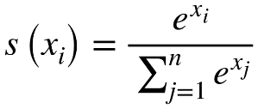

Where xi is the output of one of the neurons of the output layer, which pertains to one class prediction. The function divides the exponential of that value by the sum of the exponentials of all values for that prediction, converting raw values, called logits, into probability values.

Figure 6 shows a representation of a full traditional CNN.

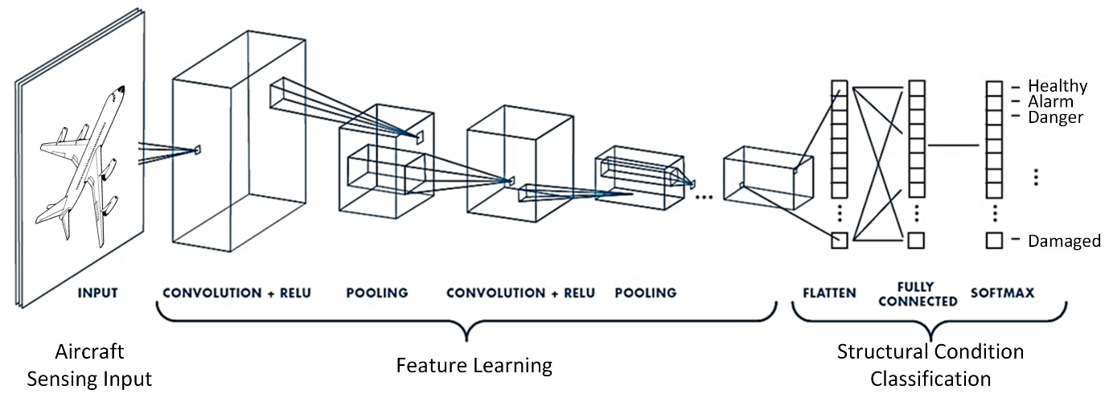

Figure 6: Architecture of a simple CNN. Source: Google Images

# 3. Study of Two-Stage Object Detection

CNNs solve the problem of image classification, but what happens if there are different objects in an image that we want to identify? If both a cat and a dog appear in an image, the CNN will only output one predicted class. This problem can be solved with **Object Detection**, which consists of finding the area of the image where the object is, and its class, as shown in Figure 7. The output of object detections models is a list of each class detected with its bounding box, which can be in the form of the coordinate x and y of the center of the box and its width and height.

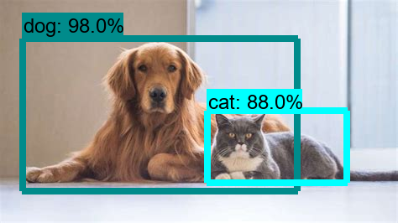

Figure 7: An example of object detection.

Early models of object detection used fixed size **sliding windows** that moved through all the image, sending each cropped image to a CNN at each iteration to classify that part of the image. If a class was found, the model considered there was an object in that place. This method has the problem of being too slow, as lots of images were passed to the CNN.

## ****3.1. Region-Based CNN (R-CNN)****

**Region-Based CNN (R-CNN)** solved this problem by reducing the number of cropped images to feed from the initial image to the CNN by using **Selective Search** before the CNN. Selective search is an algorithm that tries to segment all the objects of an image at different scales and containing components of different color and texture, like the images in Figure 8, more precisely than traditional image segmentation algorithms.

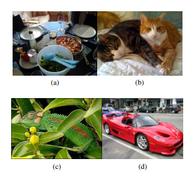

Figure 8: With simple image segmentation, the image is segmented by color and texture, so the car could have its wheels in a different group than its chassis, or it would be difficult to detect the whole span of the table containing dishes.

After an initial segmentation and saving the bounding boxes spanning each group, selective search uses a greedy algorithm to combine each group to its closest neighbor, computing that “distance” in terms of color, texture, size, and shape. The bounding boxes of the new combined groups are saved as well. Selective Search keeps doing iterations of combining groups and saving their bounding boxes until only one group remains. Figure 9 shows the results from Selective Search at different iterations.

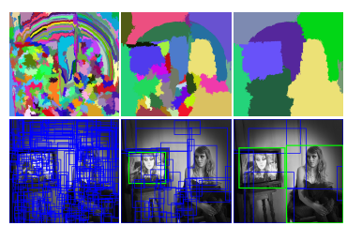

Figure 9: The left most image shows the original segmentation, with its corresponding bounding boxes. Each iteration gets fewer groups and bounding boxes as they combine with each other, being able to have the whole woman from the right in one group and bounding box.

R-CNN takes the bounding boxes from the selective search as input, which would be around 2000, using each image inside them on a CNN, which is called “**backbone**”, to classify them and predict which object contains, thus reducing the number of images to feed to the CNN compared to the sliding window method. The backbone tends to be a popular pretrained image classification model, such as **ResNet** or **EfficientNet**, which have good accuracy scores on big image datasets like **ImageNet**. After the classification of each region is done, the four values describing the bounding box position are used as input for a regressor that adjusts their values using the ground truth to improve the precision of the detection. Figure 10 shows a representation of the R-CNN architecture.

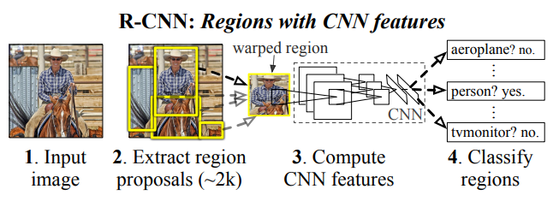

Figure 10: Architecture of a R-CNN. An extra bounding box regression layer is added next to the classifier. Source: []

During training, the **Intersection over union (IoU)** (see Figure 11 and chapter 5.4)between predicted boxes and ground truth boxes is computed. If the prediction and the ground truth are the same, the IoU will be equal to 1. Predicted bounding boxes with IoU > 0.5 **are considered true for their detected class** and the rest are considered negatives, by assigning them the class “background”. Bounding boxes that have an IoU higher than 0.3 with respect to another bounding box with higher IoU with the same ground truth box are considered overlaps and classified as negative.

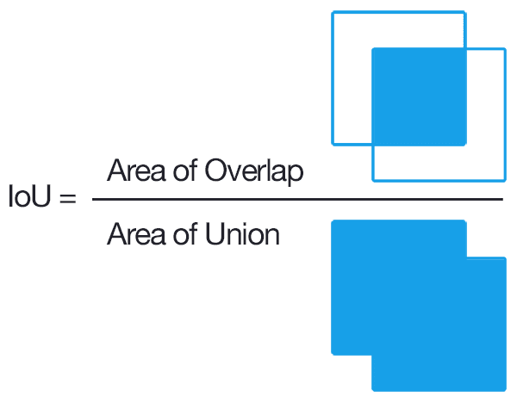

Figure 11: Visual representation of the IoU formula. Source: Google Images

During inference, a similar method is commonly used in Object Detection models in general to only output the most relevant bounding boxes, called **Non-Max Suppression (NMS)**. This algorithm starts removing bounding boxes with a lower **classification score** than a specified threshold, then, for each class, it sorts the remaining bounding boxes using their probabilities and pick the highest scoring one, which is removed from the list and marked as the “current element”.

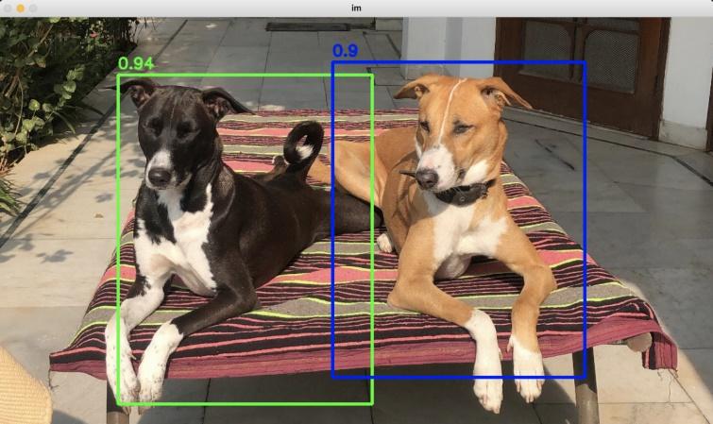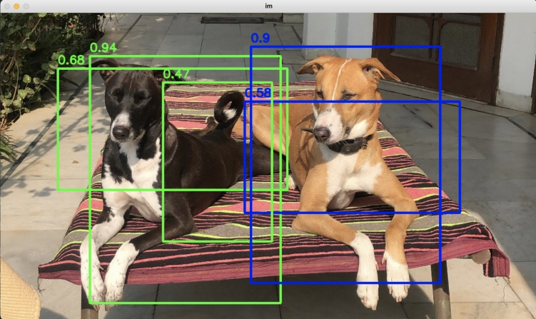The **IoU** of that element with each of the remaining boxes from the list is computed and if it is above a specified threshold, the box from the list is deleted. Finally, the “current element” is added to the “final list”. The process of picking the highest scoring bounding box and deleting the rest depending on their IoU is repeated until there are no boxes left on the initial list, and the “final list” is returned as output. Figure 12 shows the result of using NMS on multiple boxes.

Figure 12: Result of using Non-Max Suppression

## 3.2. Fast R-CNN

R-CNN has the drawback of still being very slow, as feeding the CNN with 2000 regions per image is still very computationally expensive and depends on the output of the selective search algorithm, which is not trainable and can generate bad region proposals from the start.

**Fast R-CNN** tries to solve some of those problems by using the whole image as input for a CNN backbone that **produces a convolutional feature map** which, like the input, is an “image” encoded as a matrix with three dimensions: height, with and color channels. Then, for each region from the **selective search**, instead of cropping the original image, the region of interest (RoI) is cropped from the convolutional feature map and goes through a **RoI Pooling Layer,** which **turns the RoI into a fixed-length (h x w) feature vector** by dividing the RoI into (h x w) subsections and picking the maximum value out of each. Each feature vector is fed to a set of fully connected layers that branch into two output layers: one that classifies the object and the other that adjusts the 4 values that encode the bounding box. Figure 13 shows the Fast R-CNN architecture.

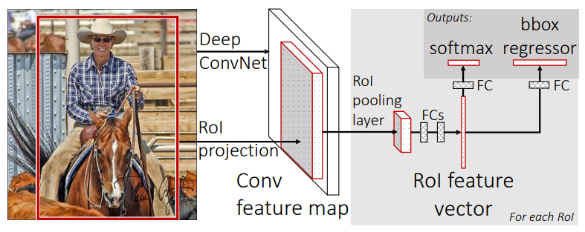

Figure 13: Fast R-CNN architecture.

Fast R-CNN does not feed 2000 images to the CNN, as the convolution operation is only done once per image, making it much faster than the original R-CNN at test time. However, it still depends on region proposals from the selective search algorithm, which are computationally expensive and affects its performance.

## 3.3. Faster R-CNN

**Faster R-CNN** avoids using region proposal methods such as Selective Search by, after generating an initial convolutional feature map like Fast-RCNN, using **Region Proposal Networks (RPN)**, a convolutional network that takes the convolutional feature map (of any size) as input and outputs a set of region proposals. Each region proposal has an **objectness score** measuring how likely that region pertains to a class and not to the background, which is computed by checking the IoU of the region with the ground truth boxes. Those region proposals are used as the input of a **Fast-RCNN** network that outputs the final detections. Figure 14 shows a representation of the Faster R-CNN architecture.

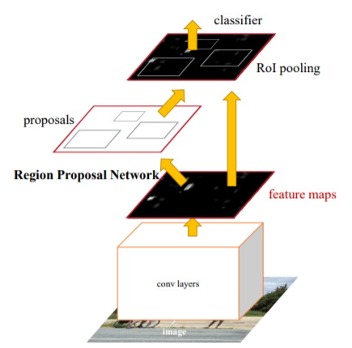

Figure 14: Representation of a Faster R-CNN. Feature maps are used both in the RPN and the Fast R-CNN

The **Region Proposal Network (RPN)** uses the output of the backbone convolutional neural network, which takes the input image after resizing it such that its shortest side is 600 pixels and the longer side not exceeding 1000 pixels. The backbone total stride is 16, meaning that for each consecutive pixel in the backbone output, the corresponding pixels in the original image are 16 pixels apart.

**RPN** uses by default **3 fixed scales and 3 aspect ratios to create 9** **“anchors”** centered in a 3x3 sliding window that slides through the feature map. These anchors indicate possible objects of various sizes and aspect ratios in the corresponding location at the original image in respect to that point in the feature map, as shown in Figure 15. The network then must check if each anchor corresponds to a real object and refine its coordinates to create region proposals that will be fed to the **Fast R-CNN**.

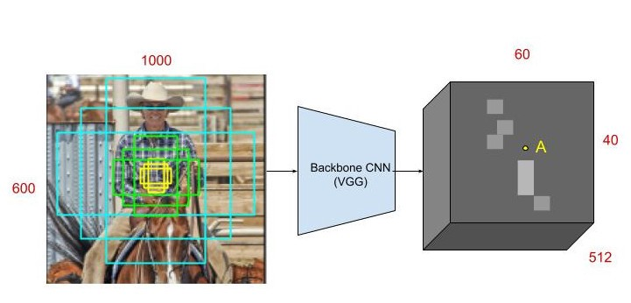

Figure 15: At point A in the feature map, 9 anchors using 3 scales and aspect ratios are generated centered at the corresponding point in the input image. Source <https://towardsdatascience.com/faster-r-cnn-for-object-detection-a-technical-summary-474c5b857b46>

The 3x3 sliding window has the form of a 3x3 convolution with 512 units, which is applied to the HxWx512 feature map, meaning each of the 512 units uses 512 kernels with size 3x3. The output is fed to two sibling 1x1 convolutional layers that carry out the “objectness” classification and the bounding box regression, respectively.

The classification layer has 18 units as it outputs two values for each of the 9 anchors: The probability of that anchor containing an object and the probability of containing the background, obtained by using the **softmax** activation. Thus, the final output is a HxWx18 feature map, that indicates the probability of there being an object inside of each of the 9 anchors in each point of the convolutional feature map.

The regression layer has 36 units, encoding the coordinates of the 9 anchors of each point of the feature map with 4 values. The regression is used to improve the coordinates of the initialized anchors that have fixed scales and aspect ratios and is only activated if the ground truth of the box containing an object is true. Figure 16 shows the detailed architecture of the RPN.

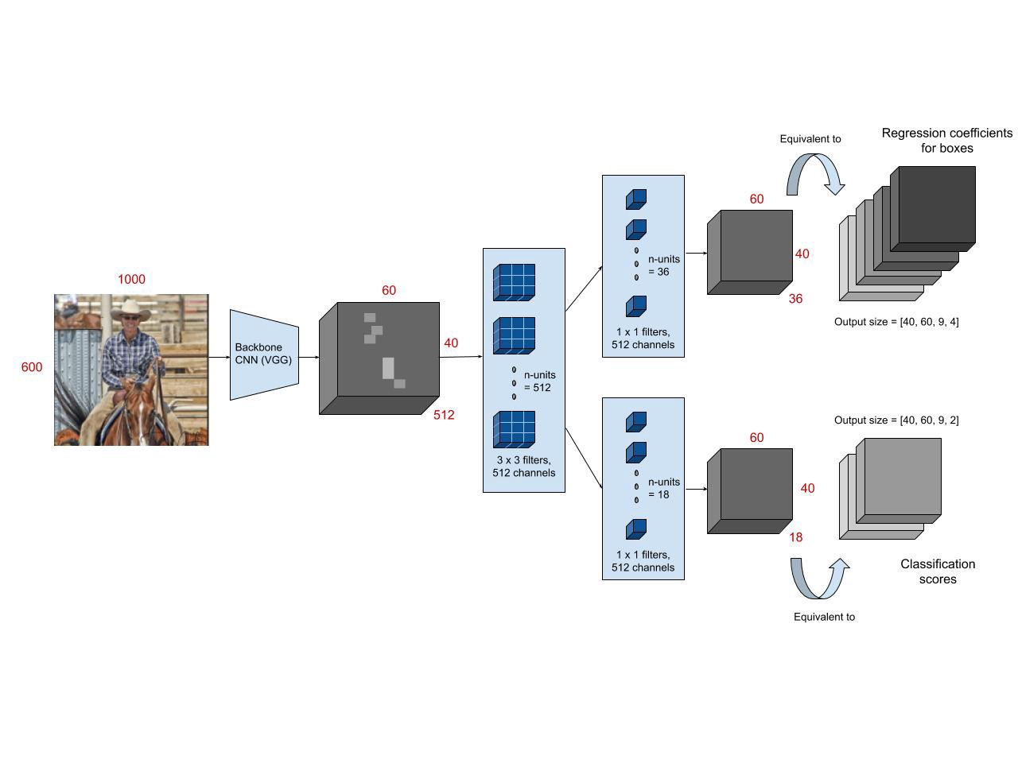

Figure 16: Architecture of a Region Proposal Network (RPN). Source: <https://towardsdatascience.com/faster-r-cnn-for-object-detection-a-technical-summary-474c5b857b46>

The total output consists of about 40x60 locations with 9 anchors in each, meaning around **20.000 anchors per image**. **During training**, however, anchors that cross the image edges are not used, leaving around 6000 anchors per image. From those anchors, RPN uses only the ones with the highest IoU with a ground truth box, or the ones with more than 0.7 IoU with any ground truth box. During test time, Non-Max Suppression is applied to the 20.000 bounding boxes, removing boxes with more than 0.7 IoU with a higher scoring one, giving around 2000 region proposals by the end.

Finally, those region proposals are fed to a Fast-RCNN, extracting them from the initial feature map, applying RoI pooling, being fed to a set of fully connected layers and then to the final bounding box regressor and classifier. Unlike the RPN regressor that has 4 different regressions (one for each coordinate) for each scale and aspect ratio combination, the bounding box regressor has 4 different regressions for each of the final possible classes.

**RPN only takes around 10 milliseconds to compute region proposals**, a considerable speed up compared to Selective Search, which takes more than one second. Faster R-CNN test time for a single image is below half a second, being able to run detections on real time videos at around **17 frames per second** using.

## 3.4. Mask R-CNN

**Mask R-CNN** builds up on Faster R-CNN, to solve a different kind of problem, called **Instance Segmentation,** while still detecting objects using bounding boxes**.**

Segmenting an image, as seen in the Selective Search explanation, means dividing the image in groups, usually depending on color, shape, and texture. **Semantic Segmentation** tries to group each object of the same class in the same group, painting the objects pixel by pixel, and coloring the objects of the same class with the same color. Those pixel-by-pixel groups are called segmentation masks. **Instance Segmentation** decouples those groups of the same class to have a **separate segmentation mask for each singular object**, having a different color each, as shown in Figure 17.

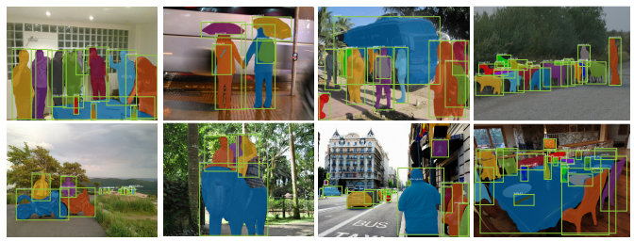

Figure 17: Examples of instance segmentation with bounding boxes.

To predict segmentation masks, Mask R-CNN adds a **parallel** **fully convolutional network** to **Faster R-CNN,** using the same extracted RoIs that are used as input for the image classification and bounding box regression. In Faster R-CNN, those extracted RoIs go through a RoI Pooling layer, that converts each extracted RoI into a feature vector of the same size, as described chapter 3.3. Figure 18 shows the Mask R-CNN architecture.

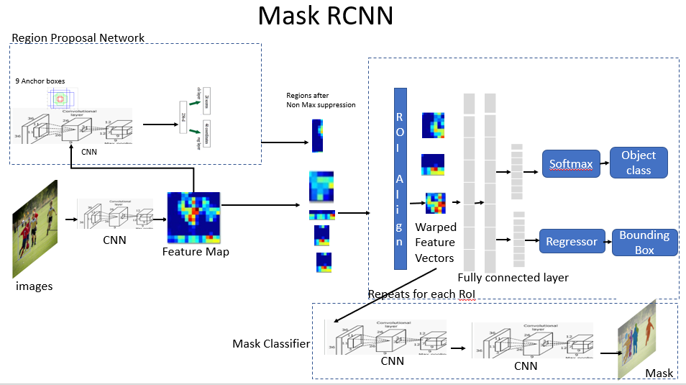

Figure 18: Mask R-CNN architecture.

**RoI Pooling causes misalignments** from the feature map as it uses rounding, which is not important for classification and bounding box detection but has a negative impact when trying to predict pixel-by-pixel segmentation masks. For example, if the RoI upper left corner is at pixel (26, 37), and the CNN that outputs the feature map has a total stride of 16, the corresponding pixels in the feature map would be at (24/16, 37/16) = (1.625, 2.3125), which, when using RoIPooling is rounded to (2, 2) and the value from that pixel from the feature map is used.

**Mask R-CNN replaces RoI Pooling with RoI Align**, which avoids rounding the coordinates by using bi-linear interpolation, so that the output is aligned correctly with the input (feature map). In the previous example, the value for the upper-left corner of the roi would be the **bi-linear interpolation** of the four nearest pixels, in that case the pixels at (1, 2) , (1, 3), (2, 2) and (2, 3) in the feature map, which is the **weighted average of the values of those four pixels**, the weights are determined by the distance between the target point (1.625, 2.3125) and each of the 4 nearby pixels. Figure 19 shows an example of RoI Align.

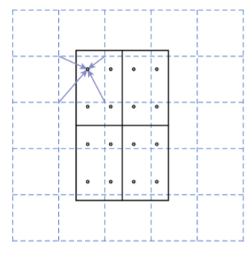

Figure 19: If the final RoI size is 2x2 (solid line), the original RoI is divided in 4 sections, and 4 regularly sampled points are used in each section (dots). The value of each sampling point is obtained using the bi-linear interpolation with its four nearest points in the feature map (dashed grid). Finally, MaxPooling or AveragePooling is used on those four sampling points to get a final RoI size of 2x2.

From the RoI align output, a **CNN branches out to predict the segmentation masks** **in parallel** to the object classification and bounding box regression, as shown in Figure 20. The architecture of this CNN is straight-forward and depends on the backbone used for the feature map generation, which can be ResNet50, which is the one used originally by Faster R-CNN, or **FPN** (**Feature Pyramid Network**) which uses convolutions of different scales and connect them horizontally to a neural network. FPN has residual layers like ResNet so the backbone is called **ResNet-FPN** and is the main backbone for Mask R-CNN.

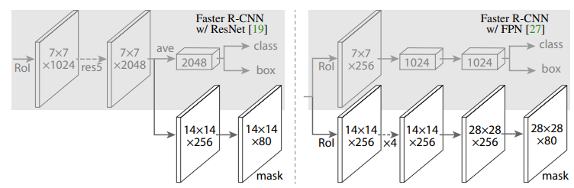

Figure 20: The CNN branch that predicts segmentation masks, depending on the backbone.

For each RoI the Mask network outputs **k segmentation masks**, one for each possible class, and the result of the Faster R-CNN object classifier decides which mask will be the final output. During inference, only masks from the 100 highest scoring predicted bounding boxes are generated, speeding up the test time. Overall, Mask R-CNN adds an overhead of 20% to the Faster R-CNN computation time, and generally runs at **5 fps** in real time detection.

## 3.5. Feature Pyramid Networks (FPN)

Historically, image pyramids were used for testing in object detection tasks, which consisted in using copies of the same image at different scales and detect objects in each of them separately to check if the model can detect the object at different scales. The feature maps generated at each scale would be different, with bigger scales resulting in more **low-level features** (meaning, more specific and less generalizable), than smaller scales.

To train more precise object detectors for multiple scales, **Feature Pyramid Networks** emulate and improve image pyramids by generating feature maps of the same image at multiple scales, created by a bottom-up CNN with a scaling step of 2 in a process called **bottom-up pathway**. Although many layers produce feature maps of the same size, those layers are considered the same network stage. The output of the final layer of each stage is considered one of the feature maps to be used. Those feature maps extract low-level features at the bottom scales, and **higher-level features** as they go up. Figure 21 compares FPN with other pyramidal methods.

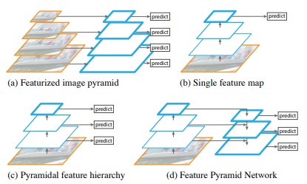

Figure 21: Differences between using convolutions on different scales of the same images (a), a normal multi-layer convolutional feature map extraction (b), using the pyramidal feature hierarchy of a convnet for predictions to emulate image pyramids (c) and Feature Pyramid Networks (c)

FPN use residual blocks like **Resnets,** meaning that the outputs of a layer are added to the inputs of other layers. The activations of the final feature maps of each stage are used as residual inputs and are called (C2, C3, C4, C5) for the convolutional layers conv2, conv3, conv4 and conv5, which have strides of 4, 8, 16 and 32 pixels with respect to the original image. The output of conv1 is not used as it would need more use of memory. FPNs often use a **ResNet-50** as a bottom-up pathway.

The network follows the first stage with a **top-down pathway with lateral connections,** which take the last output of the bottom-up pathway, which is the smaller in scale, passes it through a 1x1 convolutional layer to reduce its channel dimensions and upsamples its spatial resolution by a factor of 2, generating the next upscaled feature map. Each upscaled feature map has a lateral connection with its sibling feature map from the bottom-up path, which has the same resolution. The sibling bottom-up feature map goes through a 1x1 convolution layer to reduce the cannel dimensions and is **added** to the upsampled result from the previous top-down feature, as shown in Figure 22. Finally, the merged maps go through a 3x3 convolution resulting in the final next top-down feature map, which is upsampled again and the process is repeated until the largest map is generated. The final set of feature maps is called (P2, P3, P4, P5) corresponding to (C2, C3, C4, C5).

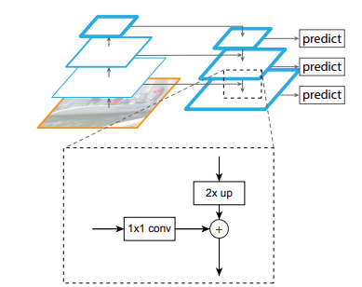

Figure 22: Lateral connections add the bottom-up feature maps to the top-down upsampled features.

Feature Pyramid Networks are not a complete object detection model, instead, they are used as a new backbone feature map for **Region Proposal Networks (RPN)** for Faster R-CNN and Mask R-CNN models. The RPN layers that predict the bounding box and objectness score are attached to each of the feature maps from the FPN, sharing the same trained parameters. Instead of using anchors of multiple scales at each step of the RPN sliding window, it only uses one scale for each of the feature pyramid levels as they already capture features at different scales. When used for RPN, FPN generates one extra feature map called P6, which is simply a stride two upsampling from P5, with no lateral connections. Fixed scales with areas of (322, 642, 1282, 2562, 5122) are used for (P2, P3, P4, P5, P6) respectively, with 3 aspect ratios of (1:2, 1:1, 2:1), resulting in a total of 15 total anchors over the pyramid. Figure 23 shows the difference of predicting different scales instead of using the last output.

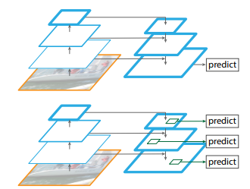

Figure 23: Predictions are carried out separately on each level (bottom) and not only on the final output (top). Source: []

FPN is also used as the backbone feature map for **Fast R-CNN**, which is used as the final object detection stage of Faster R-CNN and Mask R-CNN models. Instead of extracting ROIs from one single feature map, they **are extracted from one of the FPN levels** **depending on the height and width of the ROI**. Larger ROIs are extracted from lower, bigger levels, and smaller from higher ones. Those ROIs go through ROI pooling to become a 7x7 feature and are fed to two fully connected layers to predict bounding box coordinates and class labels as usual.

# 4. Study of One-Stage Object Detection

Although Faster R-CNN gets closer to real-time object detection, it does not get near to the standard 24 fps in movies or 60 fps or more that modern videos can achieve. Even after optimizing the test time, Faster R-CNN and similar models still rely on a region proposal stage before the final classification and bounding box regression stage, thus being called two stage object detection models.

One-Stage object detection models try to detect objects without the region proposal stage, increasing the detection speed and achieving real time object detection.

## 4.1. You Only Look Once (YOLO)

While models such as Faster R-CNN use a pretrained object classification backbone on region proposals and bounding box regression separately **YOLO** approaches object detection as a single regression problem by predicting the class and bounding box coordinates in the same layer and by processing the input image **only once**.

To do this, YOLO splits the image into an **S x S grid**, for each grid cell, it predicts **B bounding boxes centered at that cell** encoded as x, y, w, h, where (x, y) are the coordinates for the **center of the bounding box**, and (w, h) represent its width and height, respectively. For each bounding box, YOLO predicts one **confidence score** that reflects how confident the model is that the box contains an object, which is like the “objectness” score from the RPN. This score is equal to the highest IOU of that box with any ground truth box. Finally, at each cell the model also predicts **C class probabilities**, which are multiplied by the confidence score at test time to get a final detection probability. Final output boxes are filtered using the usual method of **non-max suppression** and their class is the highest scoring class probability in the grid cell where the box is centered.

YOLO was trained with the parameters S=7, B=2 on the Dataset Pascal VOC, which has 20 labelled classes, so C=20 and the final output tensor shape was 7 x 7 x (5 x 2 + 20) = 7 x 7 x 30.

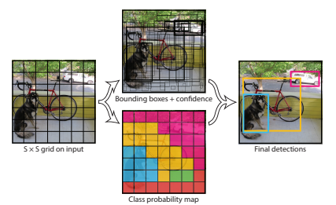

Figure 24: YOLO divides the original resized image into a S X S grid, predicts B bounding boxes and C class probabilities for each cell and a confidence score for each box. These predictions are encoded as an S x S x (5 x B + C) tensor.

YOLO is implemented as a convolutional neural network with no pretrained backbone. It has 24 convolutional layers followed by 2 fully connected layers, with the final layer generating the output as a 7 x 7 x 30 tensor.

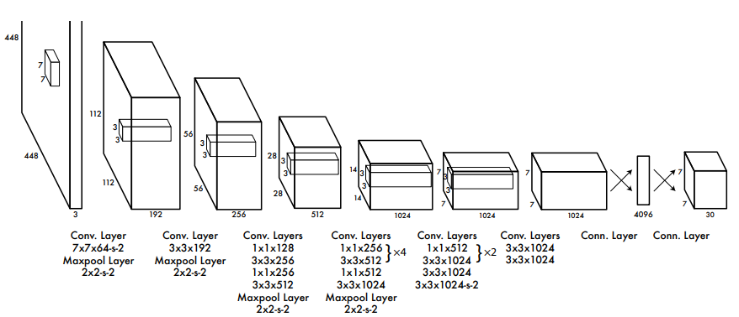

Figure 25: The YOLO network architecture. The image only goes through the convolutional network once.

As YOLO has no pretrained backbone, the first 20 layers, followed by an average pooling layer and a fully connected layer, were first trained on the classification dataset **Imagenet** as a classification model, and then those learned features were used on the final YOLO model to learn object detection faster. The process of using pretrained models and changing the final layers to get a different output is called **Transfer Learning** or **fine tuning** and is useful to get good results with only a few trainable layers as the general features were learned on the pretrained ones.

By avoiding splitting the problem into two stages, YOLO achieves an inference speed of **45 frames per second**, beating Faster R-CNN by a big margin and achieving real time object detection with good detection accuracy of **63.4 mean Average Precrision (mAP)**, while **Faster R-CNN had more than 70** **mAP**.

The main limitation of YOLO is that it has spatial constrains, **as each grid cell can only predict one class** and two bounding boxes, struggling with small objects that appear in groups such as flocks of birds. YOLO also struggles with bounding box sizes and aspect ratios that has not learned on its training dataset, as it **learns the boxes coordinates from scratch**, instead of using anchor boxes like Faster R-CNN.

## 4.2. YOLOv2

YOLOv2 (or YOLO900) improves the original YOLO accuracy and speed by tuning the neural network layers, training the network with randomized image rescaling, adding a residual layer from a bigger feature map to the final one and adding **batch-normalization layers,** which **standardize** the layer outputs of a batch, making them have a mean of 0 and a standard deviation of 1.

But the biggest change in YOLOv2 is the adoption the **anchor box** system from Faster-RCNN (RPN) instead of having the network predict the boxes coordinates from scratch. YOLOv2 also **decouples the class prediction from the cell location**, predicting it for each anchor box along with the objectness score instead. As the original YOLO only predicted 2 boxes per cell grid on a 7x7 grid, it predicted a total of 98 bounding boxes. With anchor boxes, YOLOv2 predicts more than a thousand.

Instead of setting anchor box sizes using handpicked scales and aspect ratios, a **k-means algorithm** is run during test time on the test dataset to find the most common bounding box shapes, using the k-means centroids as the anchor-box sizes. YOLOv2 also tunes the anchor box system by making it predict the box locations relative to the location of their grid cell instead of the full image.

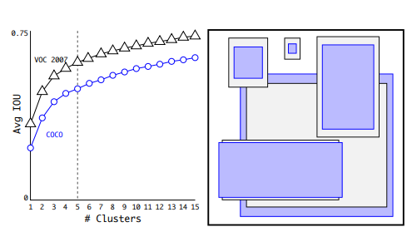

Figure 26: Using K-means to get the main box shapes.

YOLOv2 has a modified backbone from YOLO, called **Daknet-19** is trained on the image classification dataset ImegeNet with **1000 different classes**. Using this pretrained network before training the model for detection after changing the last layers makes the model able to detect objects of classes that are not included on the detection dataset.

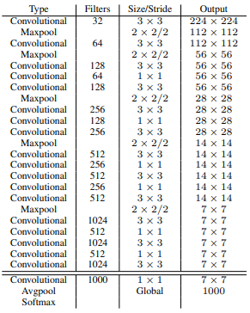

Figure 27: Darknet-19 architecture with the image classification head

## 4.3. YOLOv3

YOLOv3 improves YOLOv2 mainly by using a new backbone, called **Darknet-53**, which makes use of **residual layers** and does predictions at **different scales** in a similar way to **Feature Pyramid Networks** (FPN).

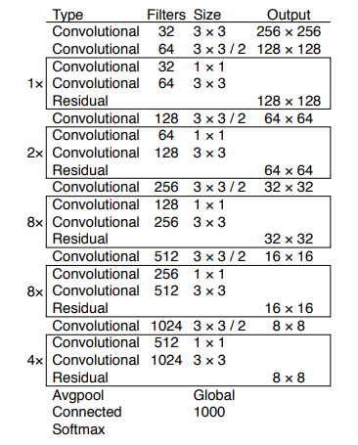

Figure 28: Darknet-53 architecture with the image classification head

Like YOLOv2, this iteration uses anchor boxes with predicted sizes using k-means. YOLOv3 will predict 3 bounding boxes at 3 different scales, so this time, 9 centroids are used as pre-chosen anchor box dimensions, called priors, and are divided evenly across 3 arbitrarily chosen scales. The last backbone feature map, which has the lower scale, will go through added detection convolution layers to predict 3 anchors boxes, where each has 4 coordinates, 1 objectness score and 80 class probabilities, resulting in a tensor of dimensions N x N x [3 * (4 + 1 + 80)] where N x N is the number of grid cells the image is divided into.

After the first set of detected boxes, the feature map from two layers before that result is upsampled by 2 and is added to a feature map from earlier in the network, which goes through the detection layers and predicts three more bounding boxes, resulting in a tensor twice the size of the previous one. This process is repeated with a previous feature map and a result of 9 bounding boxes is predicted.

YOLOv3 achieves an inference time of less than 50 milliseconds, achieving between 30 and 50 fps on videos, while having a mean average precision mAP on the COCO dataset (also called COCO AP) between 28 and 33. At the time of its release, YOLOv3 was slightly less precise than the state-of-the-art detection models (in terms of precision) such as Faster R-CNN, but was a lot faster.

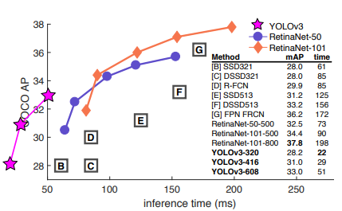

Figure 29: Comparison between precision and inference time of detection models in respect to YOLOv3

## 4.4. YOLOv4

By the time YOLOv4 was released (2020), most object detector models had a similar structure where there was a backbone, neck, dense prediction and sparse prediction. The **neck** are layers between backbone and head that carry out the collection of feature maps at different stages of the backbone, having bottom-up and top-down paths like an FPN. The **dense prediction** stage is where bounding boxes are predicted from the layers of different scales of the neck, like **RPN** for two stage detectors and **YOLO** for one stage The **sparse prediction** stage is exclusive to two stage detectors, where the dense predictions (**ROI**s) go through the final detection layer, like in Fast R-CNN.

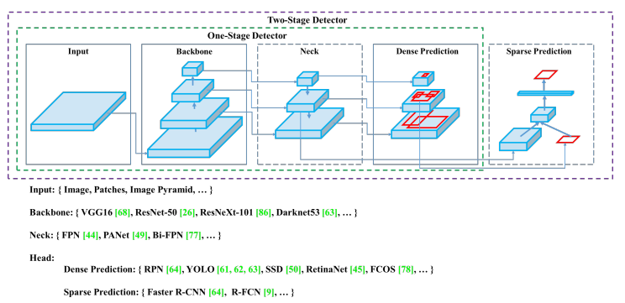

Figure 30: The standard Object Detection Architecture

YOLOv4 groups its improvement methods into two categories. The first one, called **bag of freebies,** includes methods that increase the model accuracy without increasing the inference cost by only affecting the training stage. **Data augmentation and Regularization** methods are part of this group. Data augmentation makes the model less prompt to overfit on the training data, as the data is changing randomly with random transformations such as rotations, change of brightness, size and more. YOLOv4 uses **CutMix**, which cuts a random region from an image and fills them with a patch from other one, and **Mosaic** data augmentation, which takes blocks of 4 different images and merges them into one. Another data augmentation technique used by YOLOv4 is Self-Adversarial Training (SAT), which modifies images in a similar way to Generative Adversarial Networks.

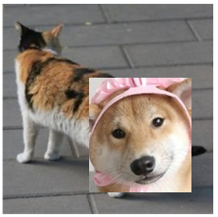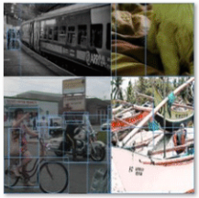

Figure 31: Examples of CutMix (left) and Mosaic (right) data augmentation. Source: Google Images

There are techniques like data augmentation applied to feature maps and not to the original image that serve as **regularization** methods, whose function is to avoid overfitting on the training data. On popular method in deep learning is **DropOut**, where random pixels from feature maps are converted to 0 (black), or **DropBlock**, where blocks of pixels are set as 0 instead of individual ones. YOLOv4 uses DropBlock regularization. **Class label smoothing** is another method of regularization, which consists of altering the class prediction results to prevent having one class probability being much larger than the others.

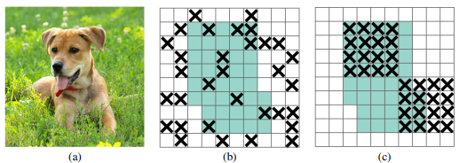

Figure 32: Examples of DropOut (b) and DropBlock (c) regularization methods on extracted feature maps from an image (a)

Another element from the bag of freebies is Cross Mini-Batch normalization, which is a modified version of batch normalization where the mean and the standard deviation are computed, normalized and acummulated to subsequent mini-batches inside the same batch.

The last element of the bag of freebies is the loss function for bounding box regression. Traiditional object detectors use the Mean Squared Error (MSE) of the 4 bounding box coordinates. However, this method treeats each coordinate as an independent variable and does not take into account the integrity of the object. To fix this issue, **loss functions based on** **IoU** are proposed. YOLOv4 uses **Complete IoU Loss (CIoU)**, which takes into account the IoU, the distance between center points and the aspect ratio similarity between the predicted and the **ground truth box**. The CIoU loss is defined as follows:

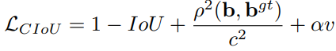

where ρ(b, bgt) is the Euclidean Distance between the boxes central points, c is the diagonal length of the smallest enclosing box covering the two boxes, α is a positive trade-off parameter, and v measures the consistency of aspect ratio with the following formula:

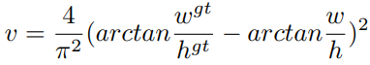

Where w and h are the width and height of bounding boxes.

The other group of improvement methods is called **bag of specials**, and include methods that improve the model precision while increasing inference time by a small ammount.

One of the modules in the bag of specials is the **enhancement of the** **receptive field**, which is the size of the input image pixels that a final feature map output value depends on. For example, the result of one convolutional iteration with a 3x3 kernel in the original image has a 3x3 receptive field. If one feature has a larger receptive field, it means its information contains a bigger context of the image.

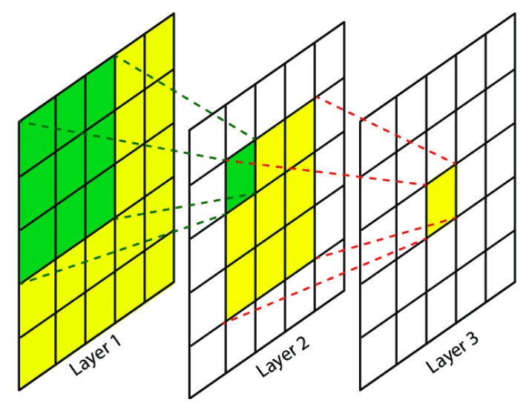

Figure 33: Example of receptive fields with 3x3 kernel size convolutions. Green cells in Layer 1 represent the receptive field of the green cell in layer 2, and green and yellow cells from Layers 1 and 2 represent the receptive field of the yellow cell in Layer 3.

**Spatial Pyramid Pooling (SPP)** is one of the methods that enhances the receptive field. SPP is similar to ROI Pooling but with multiple scale outputs, it uses a feature map and divides it into multiple N x N grids with different values of N, and then uses max-pooling on the pixels inside each separate cell, flattens each grid output and concatenates them in a single one dimensional vector. As a one dimensional output is not fit for using it as a feature map, YOLOv4 uses a modificed version of SPP by converting it into a concatenation of max-pooling outputs of k x k sized kernels where k = {1, 5, 9, 13} and stride 1. This results in multiple feature maps of the same size but with different receptive field sizes. The SPP module is added after the final layer of the backbone.

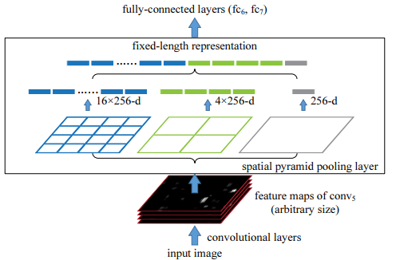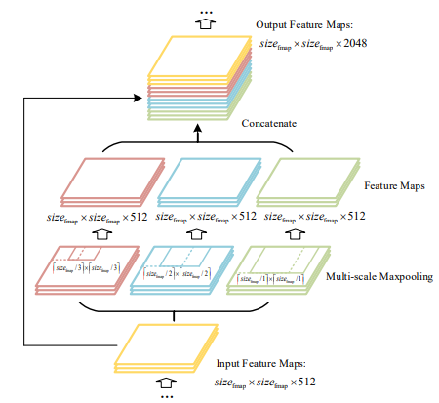

Figure 34: Representation of Spatial Pyramid Pooling (SPP) (left). YOLOv4 modifies SPP to have feature maps as output (right).

Like **FPN**, YOLOv4 uses bottom-up paths and top-down paths with lateral connections. Instead of using FPN like YOLOv3, YOLOv4 uses a modified version of **Path Aggregation Networks (PANet),** that includes another bottom-up path after the top-down path with lateral connections, called **bottom-up path augmentation**. YOLOv4 modifies PAN lateral connections to **concatenation** instead of addition. The PAN takes outputs from different layers of the backbone as well as the SPP output as its smallest scale input (the top of the top-down path), and **the final feature maps from each PAN stage are fed to a YOLOv3 head** that uses 3 anchor boxes on each stage to predict a total of 9 bounding boxes per pixel, each with their objectness score and class prediction.

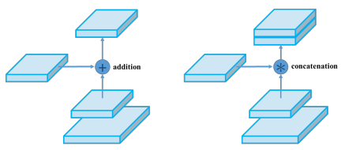

Figure 35: Original PAN aggregation method (left) and the YOLOv4 PAN modification (right). Source: []

An additional block is added to the neck, the **Spatial Attention Module (SAM),** which makes use of the attention mechanism. Attention is referred as a mechanism in deep learning where one feature “looks” at previous inputs. For example, in a neural network that translates sentences from one language to another, the output translation of a certain word might depend on previous words, so the network has an attention mechanism where it considers the importance of previous words for that input, usually in the form of a vector with the same size as the input size, with the values representing the importance ratio between 0 and 1. Spatial Attention translates this mechanism to images or feature maps, where each pixel has its attention value.

**SAM** does this by concatenating the results of a max-pooling and average-pooling layers over the input, and applying a convolution with a sigmoid activation function, resulting in the spatial wise 2D attention map, which is multiplied with the original 3D input, having each channel value multiplied by the attention value of its (x,y) position, to get the final result. YOLOv4 modifies SAM by avoiding the max-pooling and average-pooling layers, and instead uses one convolution layer with the output of the same size as the input with a **sigmoid activation** to get a **3D attention map**, which multiplies each pixel of the input by the attention pixel at its (x, y, z) position, as shown in Figure 36. This modified SAM block is added in the **PAN** module after each lateral connection between the bottom-up path augmentation and the previous top-down path. Figure 37 shows the full detailed architecture of the PAN neck for YOLOv4, as well as its YOLOv3 detection head.

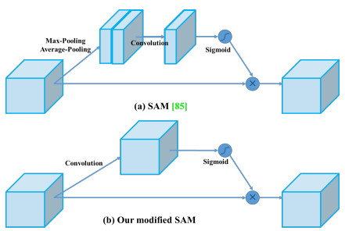

Figure 36: The original SAM (top) and modified SAM for YOLOv4 (bottom). Source: []

Another element in the bag of specials is the change of the **activation function** for most layers from ReLU, which outputs 0 for every negative input, to **Mish**, which can make the gradient more efficiently propagated without much extra computational cost and proved to be more effective for YOLOv4. The **Mish activation function** is defined as: **f(x) = x*tanh(softplus(x))**, where the softplus function is defined as follows: **softplus(x) = ln(1+ex).**

The last element in the bag of specials is the modification of the **Non-Max Suppression (NMS)** algorithm. YOLOv4 uses **DIoU NMS** instead, which uses **Distance IoU (DIoU)** to filter out boxes instead of normal IoU. DIoU is the **CIoU** formula without the aspect-ratio parameter, which is defined as follows:

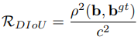

And **DIoU NMS** has the following logic:

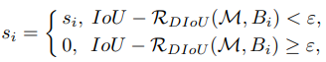

Where Ꜫ is a set threshold parameter.

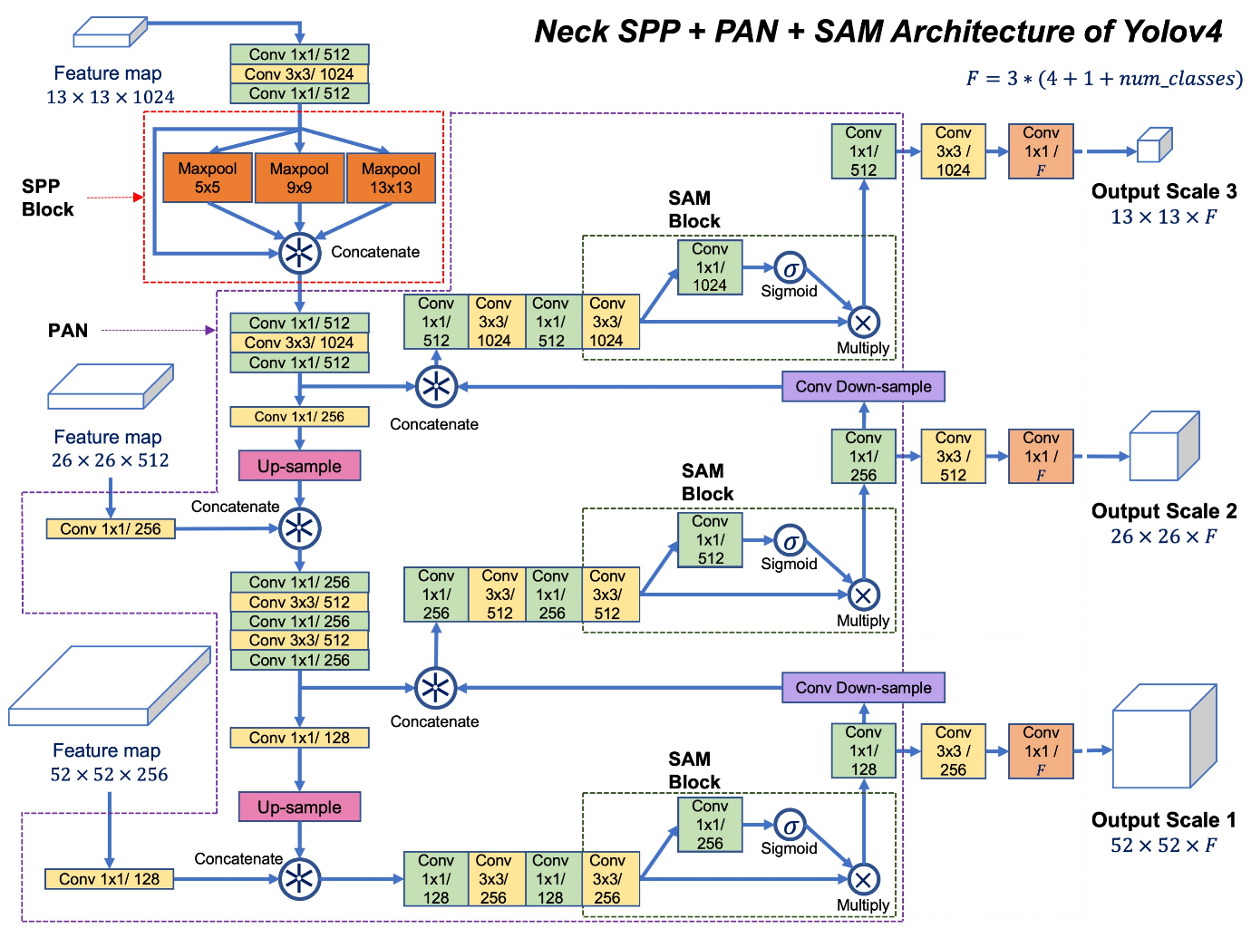

Figure 37: Inside the YOLOv4 SPP + PAN neck and YOLOv3 head. Source: corrected image personally from []

YOLOv4 uses the same backbone as YOLOv3, the DarkNet-53, but it modifies it by using **Cross-Space Spatial connections (CSP),** which splits feature maps into two copies, has each copy go through convolutional layers and concatenates the results of both copies afterwards.The backbone is then renamed to **CSPDarkNet-53**.

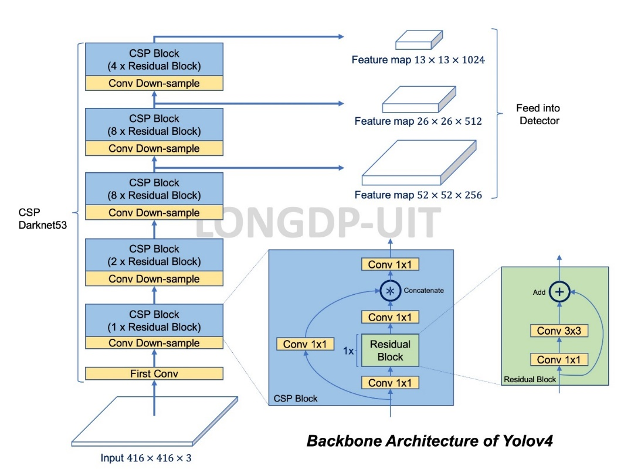

Figure 38: Architecture of CSPDarknet-53. It has 5 CSP blocks that contain a different number of residual blocks. The outputs of the last 3 CSP blocks is fed to the PAN neck, having the last output go through the SPP first. Source: []

YOLOv4 has the mindset of being able to be trained and tested on single standard GPUs while achieving real time inference and became the start of the art of real-time detectors when it released in 2020, achieving **43.5% mAP** on COCO dataset at a real time speed of **65 FPS** on a Tesla V100 GPU.

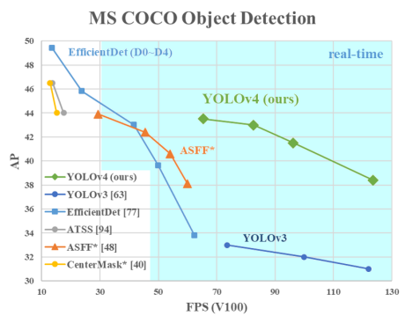

Figure 39: Comparison of YOLOv4 and other state of the art object detectors at the time of its release.

## 4.5. YOLOv5

What started as a **YOLOv4** **Pytorch** implementation with few changes has now become the most popular real-time detector. The nature of YOLOv5 is quite different from previous models, as **it is not a research project and does not have a research paper**, instead, it has a whole company behind its **continuous development** and is being constantly updated with tweaks to the architecture or adding support with different third-party software. YOLOv5 also features models of different “size” options, from faster and less precise models to slower and more precise ones that uses more different feature map scales for anchor box prediction.

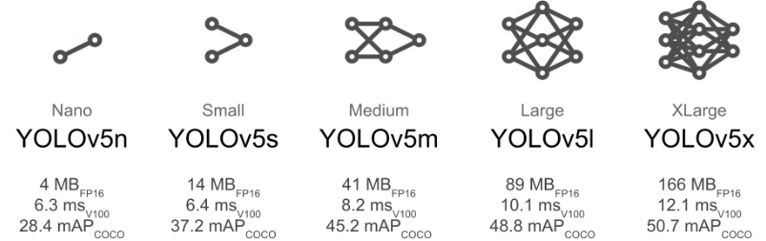

Figure 40: Size options for YOLOv5 with their COCO precision and inference speed on a Tesla V100 GPU. Source []

The continuous development and improvement of YOLOv5 makes it difficult to describe its changing architecture with detail, which can be checked in the source code, but **its general structure is the** **same as YOLOv4** with small changes to layer placement and parameters. The bigger options of YOLOv5 at the 6.0 version include **1 extra output layer**, changing the downsample and upsample rates to use 4 feature maps with lateral connections and predicts boxes at **4 different scales** instead of 3.

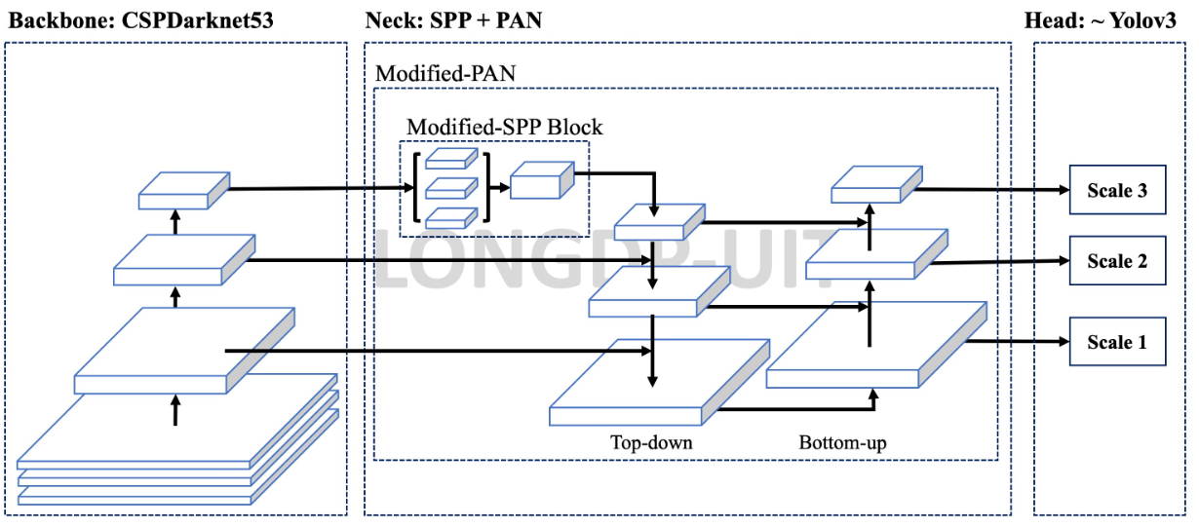

Figure 41: The general architecture of YOLOv5 is the same from YOLOv4. Source []

YOLOv5 replaces the **Mish** activation function with **SILU**, which is equal to the **sigmoid function** multiplied by its input, giving a similar output to RELU, has a modified SPP block, called **SPPF,** uses different formulas for box coordinates calculation and uses a different method for anchor box templates assignment to grid cells by having cells use ground truth boxes centered at the edge of an adjacent cell. YOLOv5 also uses more data augmentation methods

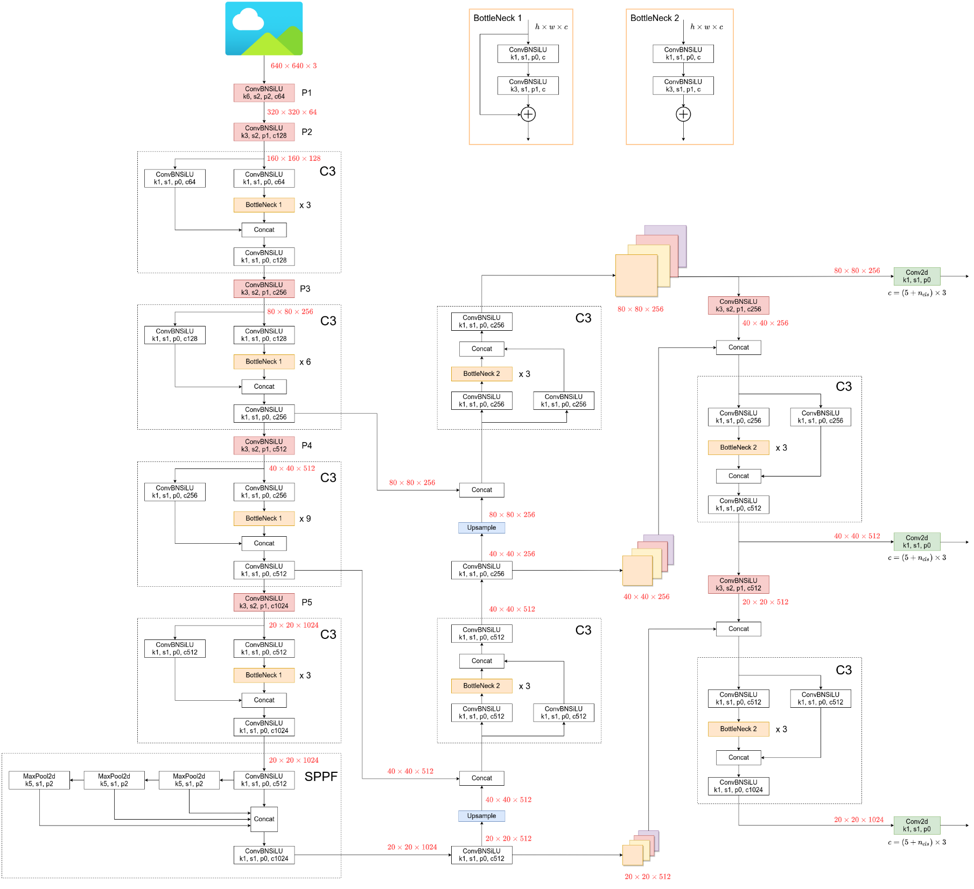

Figure 42: YOLOv5 6.1 detailed architecture, YOLOv5l (large option) in particular. Source and more details at: <https://github.com/ultralytics/yolov5/issues/6998>

## 4.6. Other One-Stage Object Detectors

### 4.6.1. Single Shot Detection (SSD)

SSD was released shortly after the first version of YOLO and was a faster and more precise model. Its main difference was using a system like **anchor boxes**, which the first YOLO lacked, and carried out **predictions on different scales**, in a similar way to the first bottom-up path from FPN.

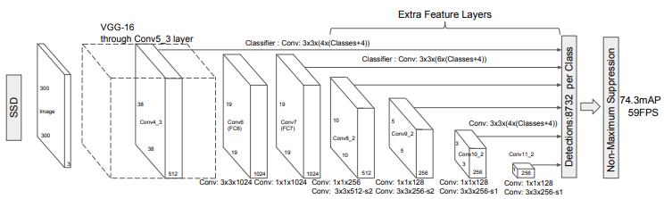

Figure 43: SSD architecture. The 74.3 mAP is the AP with 0.5 IOU threshold on the VOC2007 test dataset.

### 4.6.2. RetinaNet

RetinaNet introduced the use of **FPN** on one-stage detectors **before YOLOv3** appeared. It used the FPN outputs on two subnetworks that predicted the class and bounding box regression **separately**.

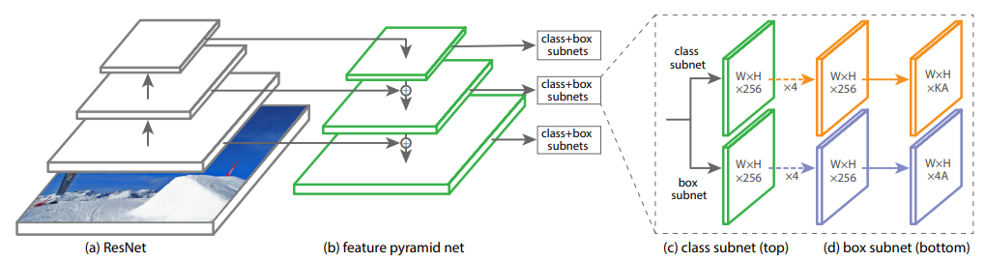

Figure 44: The RetinaNet architecture

### 4.6.3. EfficientDet

The main feature of EfficientDet is the use of a modified FPN called **Bi-directional Feature Pyramid Network (BiFPN),** which has multiple top-down and bottom-up paths like **PANet,** but with different lateral connections**.**

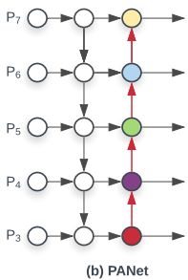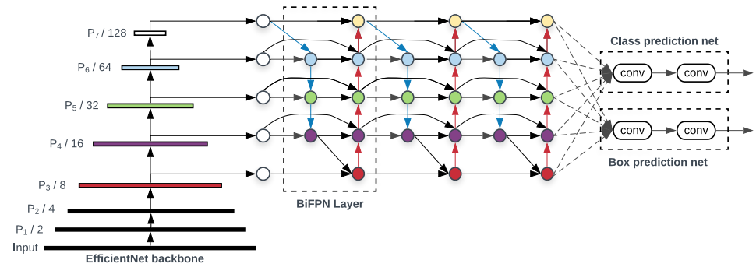

Figure 45: EfficientDet architecture (left). The BiFPN Layer is a modificed version of PANet (Right). Source: []

# 5. Evaluation Methods for Object Detection Models

Although this project focuses on the inference speed of object detection models to apply them on real time videos, it is also important to evaluate how accurate those models are at detecting objects.

For normal image classification, metrics such as **Accuracy, Precision and Recall** are usually used. **Accuracy** is the most straight forward metric as it simply measures the percentage of correct predictions by comparing them to the ground truth. For **object detection**, precision and recall are more important, and the **Intersection over Union (IoU)** is used to compute them.

## 5.1. Precision

The model precision for a given class is the **ratio** of **correctly** made **positive predictions of that class**, also called **True Positives (TP), over the total number of positive predictions for that class,** which could include incorrect positive predictions, also called **False Positives (FP).** The precision is defined by the following formula:

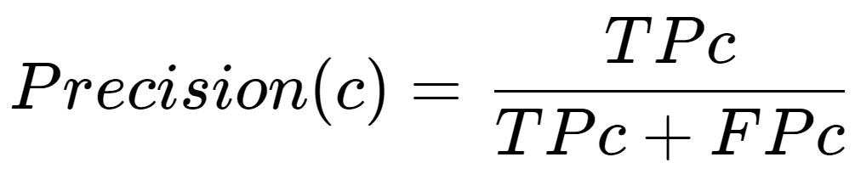

Where c is a given class, TPc is the number of True Positives of that class, and FPc the number of false positives of that class. Precision measures how close the model is to being right in all its positive predictions and is not affected by **incorrect negative predictions,** called **False Negatives (FN)**, which are positive in the ground truth. That means that precision will be equal to 1, its maximum value, if the model only predicts one True label out of hundreds and that one prediction is correct.

## 5.2. Recall

Recall is, for a given class label, **the ratio of correctly made positive predictions of that class (TP)** **over the total number of ground truth instances of that class**. The total number of positive ground truth instances of a class can also be computed as the total number of True Positives (TP) plus the total number of **False Negatives (FN)**. The recall is defined by the following formula:

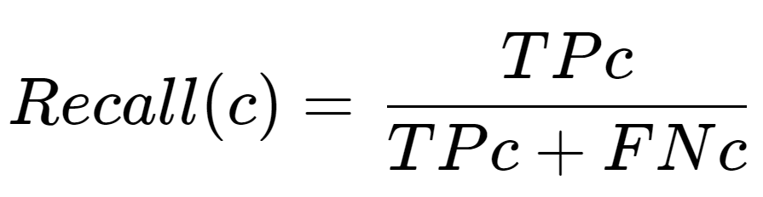

Where c is a given class, TPc is the number of True Positives of that class, and FNc the number of false negatives of that class. Recall measures how close the model is to not miss any ground truth True label of that class and is not affected by incorrect True predictions, called **False Positives (FP)**. This means that Recall will be 1, its maximum possible value, if a model predicts every instance as positive arbitrarily.

## 5.3. Average Precision (AP)

If a model arbitrarily predicts only one True label, and is a True Positive, Precision will be 1 but recall will be close to 0, as it will have lots of False Negatives (FN). On the other hand, if the model predicts all instances as positive, recall will be maximized but precision will be close to 0, as there will be lots of false positives (FP).

Thus, one way to evaluate a model is by leveraging the **Precision-Recall Curve**, which is a graph with precision and recall as axes, with each iteration having a different **confidence threshold** for the model predictions to be considered positive. With a confidence threshold of 0.1, all predictions that have 0.1 confidence or more of an object pertaining to that class will be considered positive.

**To evaluate the Precision-Recall Curve, the area under the graph is computed**, which will be always between 0 and 1 given the maximum values for Precision and Recall is 1, and that value is called **Average Precision** **(AP)**, as shown in **Figure XX.**

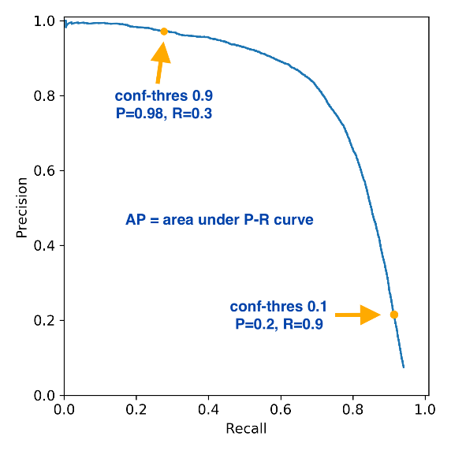

Figure 46: Example of a Precision-Recall curve. Source: Google Images.

## 5.4. Intersection Over Union (IoU)

It is trickier to know if a predicted bounding box should be considered a TP or FP in comparison to simple image classification, where each class is given a confidence score. In object detection the bounding box shape and position are important as well to determine if the prediction is correct, and the IoU is used for that. **The Intersection over Union (IoU)** evaluates the similarity between two bounding boxes and is computed by **dividing the area of their intersection by the area of their union** and is defined by the following formula:

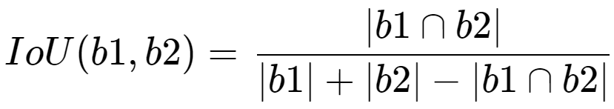

Where b1 and b2 are bounding boxes and |·| is the area. IoU ranges from 0, where the two boxes do not intersect at all, to 1, where the boxes are identical and in the same position. For evaluation metrics, **IoU thresholds are used to determine if one detected box is a True Positive (TP) or a False Positive (FP)**. If a detected box IoU **with a ground truth box with the same class label is above the IoU threshold**, **that detected box is considered a TP, otherwise it is considered a FP**. Ground truth boxes with no TP detected boxes attached are considered FN.

## 5.5. Mean Average Precision (mAP)

Originally, the **Mean Average Precision (mAP)**, also called **mAP@0.5** of object detection models was the **mean of Average Precisions over all classes** with an **IoU threshold of 0.5**. To plot the Precision-Recall-Curve of a class, all the predicted boxes are **sorted by their confidence score from maximum to minimum** and a loop iterates over them, considering one prediction as a **TP if the IoU with the ground truth box is over 0.5 and as a FP otherwise**, and the precision and recall for that given instant is computed and saved in an array. If two predicted boxes are attached to the same ground truth box with IoU above the threshold, the one with higher confidence is considered a TP and the other a FP.

The precision is computed by dividing the TP by (TP + FP) **at that given iteration**, which is usually equal to 1 on the first iteration where the confidence score is higher and there is only one TP and zero FP. The recall is always computed by dividing TP at that iteration by the total number of ground truth boxes, being close to 0 in the first iteration as there would be 1 TP and a larger number of ground truth boxes.

The Precision-Recall curve is plotted using the results for each iteration, and the Average Precision (AP) is computed by finding the area under the curve. The process is repeated for each class and then the mean AP is computed, resulting in **mAP@0.5.**

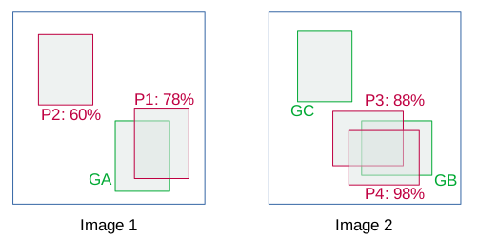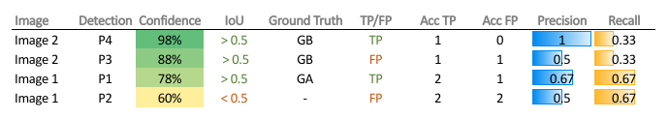

Figure 47: Representation of the process of creating a Precision-Recall for object detection. The values from the Precision and Recall columns are used to plot the curve. Source: []

If a different IoU threshold is used, for example 0.75, the resulting metric would be **mAP@0.75**. Other IoU thresholds would result in different curves, as shown in Figure 48. The **COCO Dataset**, which includes images with detection labels of 80 different classes and is a benchmark of object detection models, created a metric called **mAP@0.5:0.05:0.95**, also called **COCO AP** or simply **mAP**, which is the **mean of mAPs over a range of 10 IoU thresholds starting at 0.5 and ending at 0.95 with a step of 0.05**.

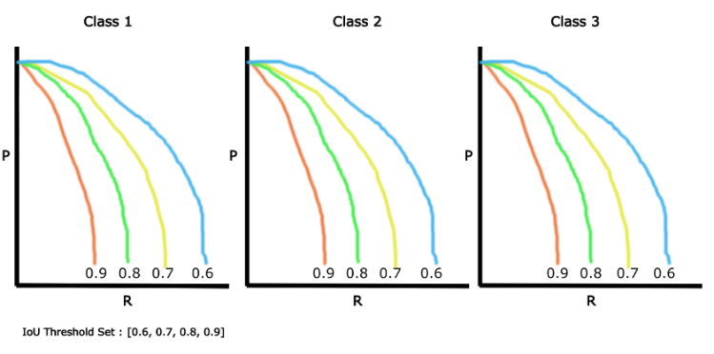

Figure 48: Example of Precision-Recall curves with different IoU thresholds. Source: Google Images.

# 6. Data Recollecting

After the study of two-stage and one-stage object detection models, it is time to use them on videos to study their performance, both speed and precision-wise. **For training, all detection models require a labelled dataset** for detection in the form of images with their annotations in the form of bounding box coordinates and class labels. It is important to **split the data in a training and validation sets**, and optionally an extra **test set**, as the model must be able to generalize what it learned during training to unknown data. If the model is trained for too long on a training dataset it will memorize that data and will probably have poor results on the validation, this problem is called **overfitting.** One way to reduce overfitting is to **augment the training data** by applying **random transformations** to the images at each training iteration, like random flips, rotations and more. I talked about this topic in chapter 4.4.

To train my models, I searched online for **public annotated datasets** for underwater species detection on real-time videos, which are not very common. I found three main options: the **Help Protect the Great Barrier Reef Kaggle competition dataset** **[TODO]**, the **FishCLEF-2015 dataset [TODO]**, and the **Luderick-Seagrass dataset [TODO]**.

## 6.1. Help Protect the Great Barrier Reef Dataset

The aim of the **Help Protect the Great Barrier Reef** competition was training a model to detect **Crown of Thorns Starfish** in images, which were extracted frames from video files. This competition served as the inspiration for this project, and I started participating in the competition with little to no background knowledge about object detection models.

I trained an **EfficientDet** model with the **TensorFlow Object Detection API**, which was unintuitive for me at the time and had lots of compatibility problems with other libraries. The model was poor at detecting objects outside the training set as I did not shuffle nor augmented the training data and trained the model for too long, resulting in overfitting. The code for this model is not included in this project as it was a training experience, and **I did not use this dataset further for this project** as I thought it was less interesting than others due to the starfish being **motionless**. Figure 49 shows one of the best results of my trained EfficientDet model on an image from the validation set.

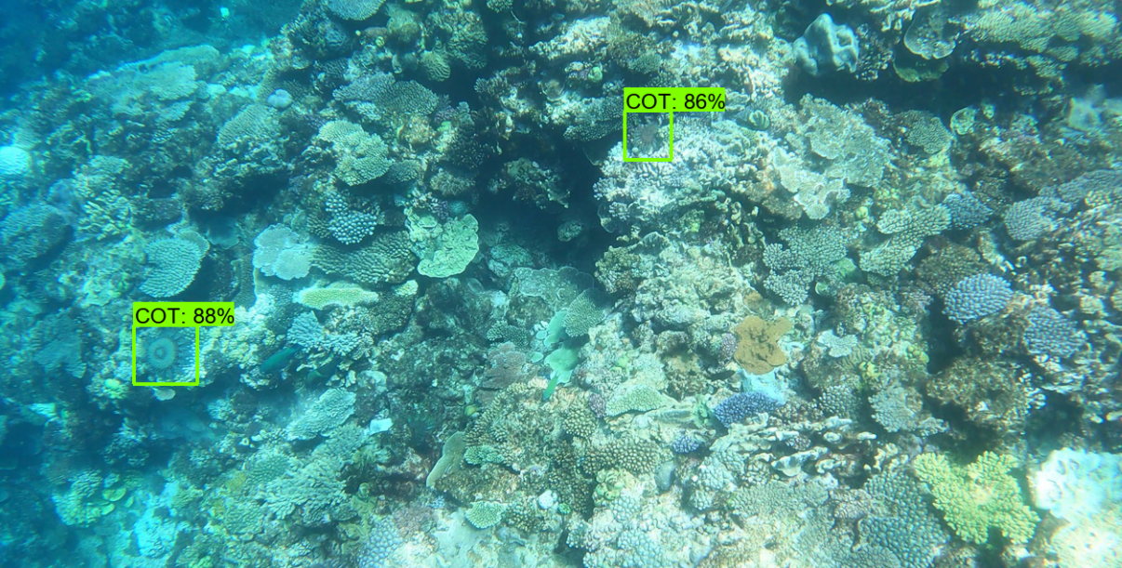

Figure 49: One output from my model for the Help Protect the Great Barrier Reef competition. Source: Own

## 6.2. FishCLEF-2015 Dataset

The **FishCLEF-2015** dataset consists of **93 videos** of underwater scenery, with detection annotation data for each frame that includes bounding boxes around **15 underwater species**. The data is unbalanced as there are more than 3000 annotation for one species while there are less than 100 for others. This dataset could have been used for this project as it is in video form and has multiple classes, but was discarded in the end due to its **poor image quality and video compression**, as it can be seen in Figure 50, which would have resulted in the model learning features that do not exist in reality, and real features and details from the species would be hidden due to the image quality.

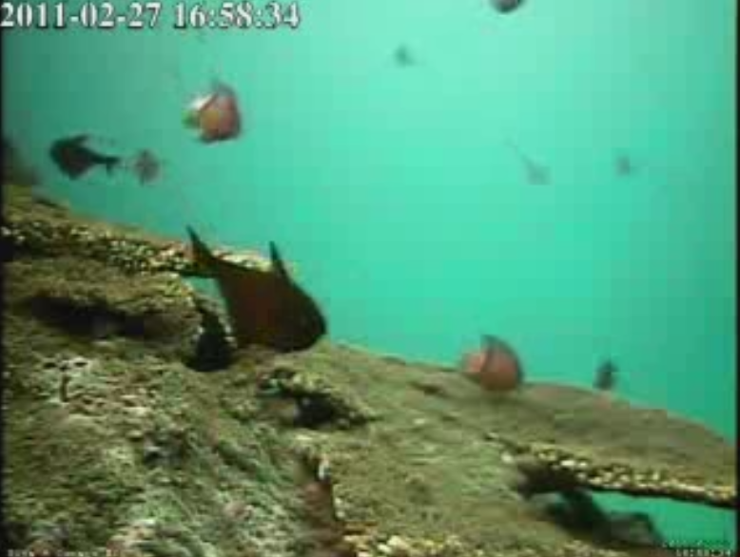

Figure 50: One frame from the FishCLEF-2015 dataset. Source: video file from the downloaded dataset.

## 6.3. Luderick-Seagrass Dataset

The Luderick-Seagrass dataset includes pre-extracted frames from video footage of the species ***Girella Tricuspidate***, also called **Luderick**, from Queensland, Australia. The dataset includes the original **video files** and the reduced number of annotated images, extracted at a rate of **5 frames per second** from the videos. Annotations include a few instances of another species, the Bream, but there are only 53 annotations for that class while there are more than six thousand annotations for Ludericks, so it cannot be considered a multi class detection dataset. **Annotations include segmentation data as well as bounding boxes,** in the form of pixel coordinates at the contours of each fish, as Figure 51 exemplifies, making it possible to train an Instance Segmentation model such as **Mask R-CNN** with this dataset.

**The Luderick dataset has been chosen for this project** for having a good amount of data in video form in **high definition at 1920 x 1080 resolution**, **easy to preprocess annotation data and the inclusion of segmentation data**. The downside of this dataset is that there is only one class to detect if we ignore the Bream.

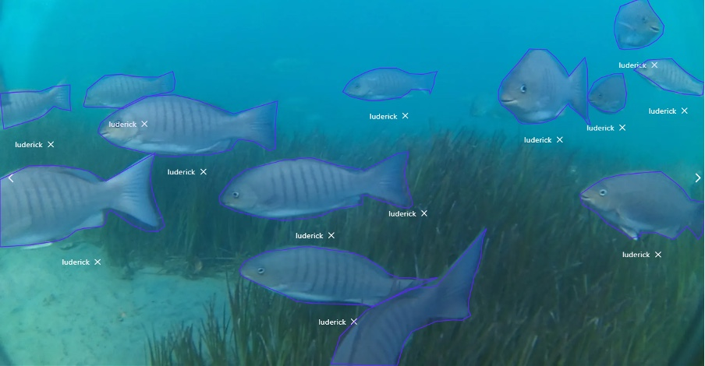

Figure 51: An example image from the Luderick-Seagrass dataset with drawn segmentation annotations. Source: []

# 7. Data Preprocessing

The Luderick-Seagrass dataset includes 9429 annotations (including Bream) and 4280 annotated images for object detection and instance segmentation. The images have been extracted from the video at a rate of 5 frames per second. The dataset has been already split into training, validation and test sets. Table 1 shows information about each split, where the class unbalance can be noticed between ludericks and Breams.

|  |  |  |  |  |
| --- | --- | --- | --- | --- |
| Dataset | Split | Luderick Annotations | Bream Annotations | Total |
| Luderick Seagrass Jack Evans A | Training | 6649 | 53 | 6702 |
| Luderick Seagrass Jack Evans B | Validation | 1632 | 29 | 1661 |
| Luderick Seagrass Tallebudgera | Test | 1023 | 43 | 1066 |
| Total |  | 9304 | 125 | 9420 |

Table 1: Details of the Luderick-Seagrass dataset splits.

All images and videos have a resolution of 1920 x 1080 pixels. Images are in JPG format and videos are in MP4 format running at 30 frames per second (fps). Figure 52: Image example from the Luderick dataset.Figure 52 shows one image from the training set where three ludericks can be seen. All images are included in the same folder and their total size is 3.5 Gigabytes. The video files can be downloaded separately, and they are only used for video inference, as there is not annotation data for each frame.

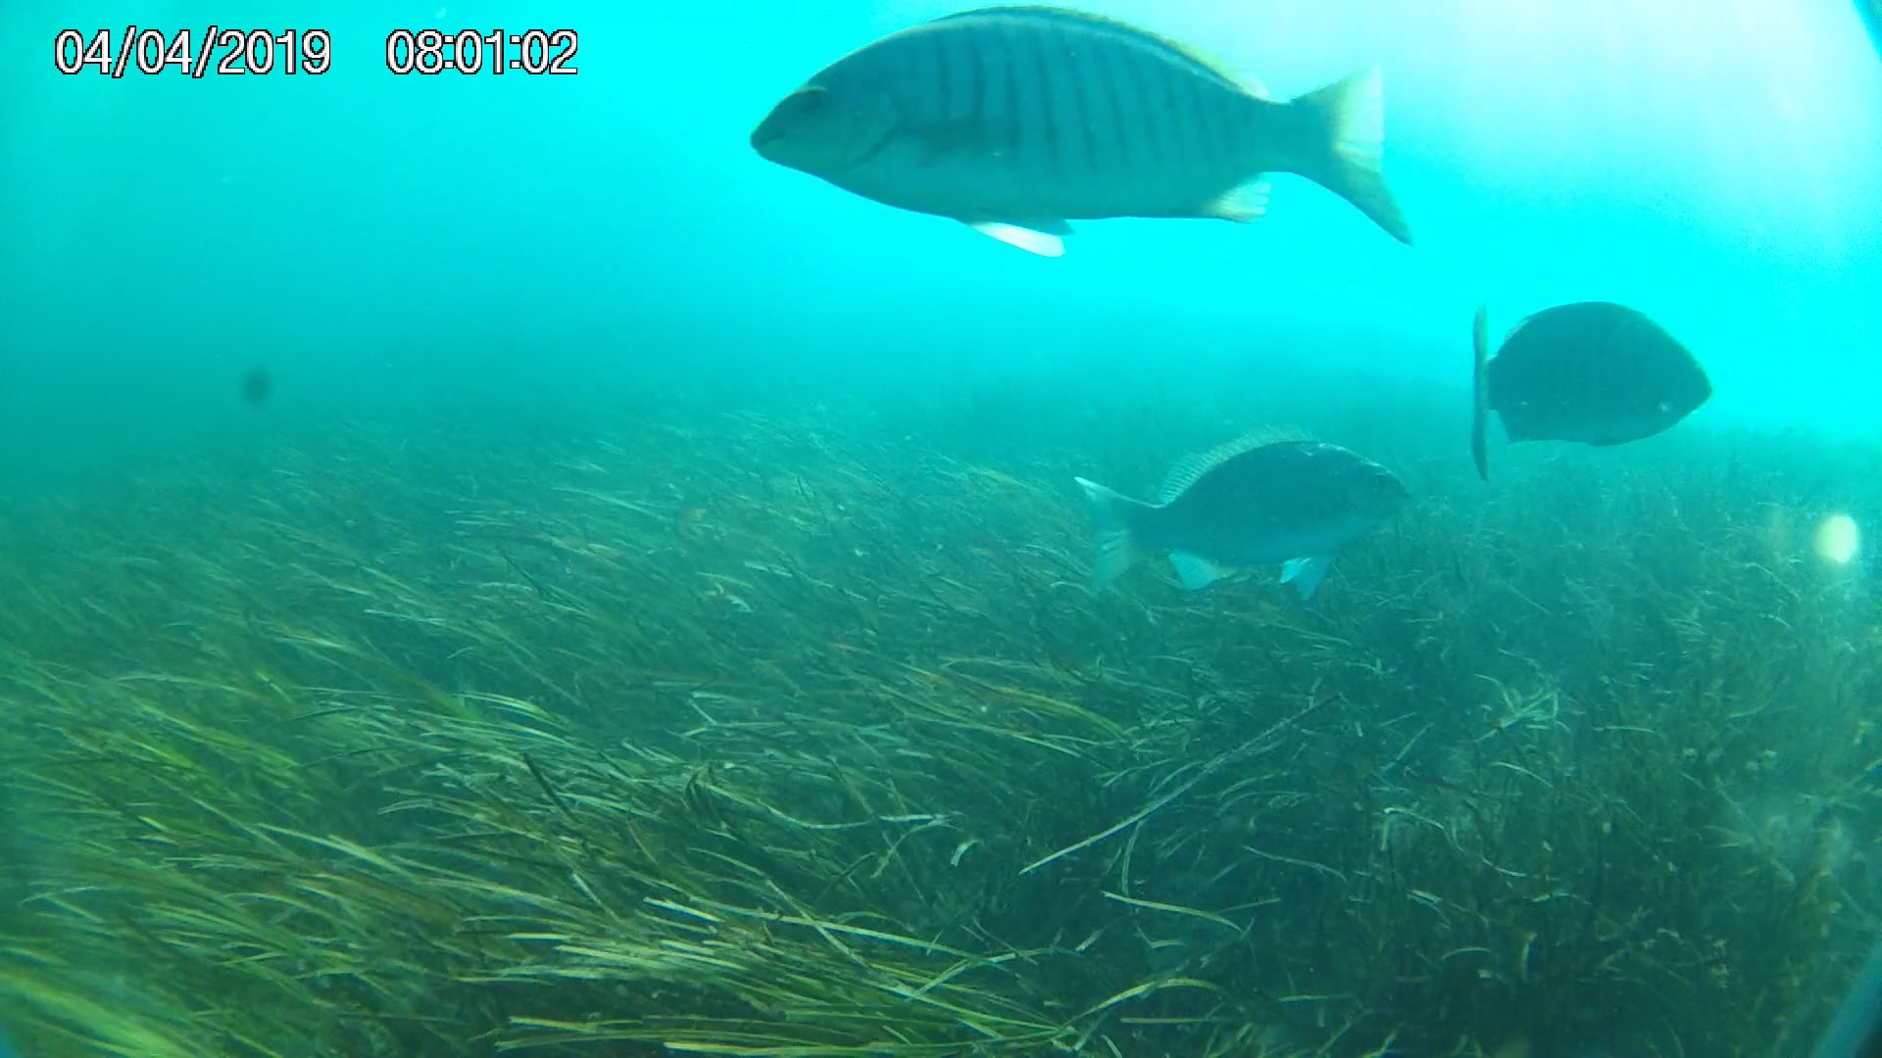

Figure 52: Image example from the Luderick dataset.

Annotations are included in two formats: The JSON format, and the **CSV format**. Both formats contain the same information, and I used the CSV format for better compatibility with the **Pandas** library for python, which can read CSV files and convert them to **DataFrames**, a data structure in a tabular form that is often used in data analysis or machine learning tasks. The CSV annotations include one row for each single object instance and includes the bounding box coordinates, the contour coordinates for segmentation, the class label, box area and the image where it appears. All images include at least one instance of a Luderick or a Bream, so there are no images with 0 annotations. Table 2 shows the structure and format of each row in the CSV annotation file format.

|  |  |
| --- | --- |
| Column | Description |
| id | INT annotation ID |
| catecory | STR name of category (luderick/bream) |
| category_id | INT category ID |
| image | STR image file name |
| image_id | INT image ID |
| bbox_x | INT minimum x pixel coordinate of bounding box |
| bbox_y | INT minimum y pixel coordinate of bounding box |
| bbox_w | INT width of bounding box in pixels |
| bbox_h | INT height of bounding box in pixels |
| area | INT area of bounding box in pixels squared |
| segmentation | STR segmentation polygon coordinates in format "[[x, y, x, y, ...]]" |

Table 2: Structure of the CSV annotations file. INT and STR refer to Integer and String format for their respective columns.

In my **Data Preprocessing Luderick Seagrass Jupyter notebook**, I start by loading the CSV annotations files for each split with the Pandas library, converting them to a Pandas DataFrame. Figure 53 shows the training split in the dataframe format.

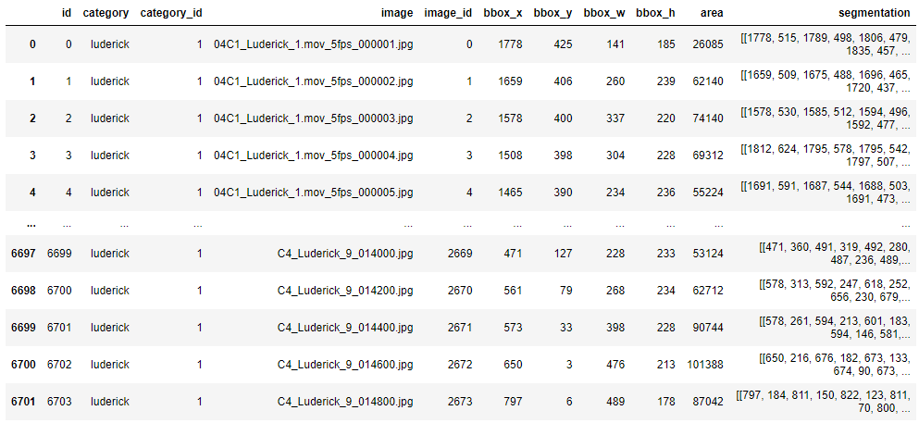

Figure 53: The training dataset in Pandas DataFrame format printed in the data preprocessing notebook. Source: Own

The annotation structure is not very convenient for analyzing the data nor for training models, which or each training example usually require one image with the list of bounding boxes and class labels included in it. To correct that, I **preprocessed** the original data to create new **preprocessed dataframes** where each row included one image and the list of **all bounding boxes** with the format [xmin, ymin, xmax, ymax]**, class labels and segmentation data**. For better data analysis, I included the name of the video from which each image is extracted, and the frame number of that image inside the video running at 5 fps. Table 3 describes the details of each column in the new preprocessed dataframe structure.

|  |  |
| --- | --- |
| Column | Description |
| image_name | STR image file name |
| video_name | STR video name |
| frame_number | INT Frame number from its respective video |
| number_boxes | INT number of bounding boxes in the image |
| labels | ARRAY(INT) class id of each bounding box (1 = luderick, 0 reserved for background) |
| bounding_boxes | ARRAY(ARRAY(INT)) list of bounding box coordinates in format [[x_min, y_min, x_max, y_max], ...] |
| area | ARRAY(INT) area of each bounding box in pixels squared |
| segmentation | ARRAY(ARRAY(ARRAY(INT))) segmentation polygon coordinates in format [[[x, y, x, y, ...]], [[x, y,...]]] |

Table 3: Column descriptions for each row of the new Preprocessed dataframe structure.

To preprocess the original dataframes I created a function called preprocess_data, shown in Figure 55, which uses Pandas functions such as **group by** to aggregate the original rows by image name and count how many bounding boxes per image or how many images per video are included. It also filters out all bream instances as the dataset is considered a single class dataset for simplicity, so images with only bream appearances will not be included in the preprocessed dataframe. The function also fixes some labeling errors where negative coordinates were given to bounding box and segmentation coordinates. Figure 54 shows the results of the preprocessed dataframe from the training set.

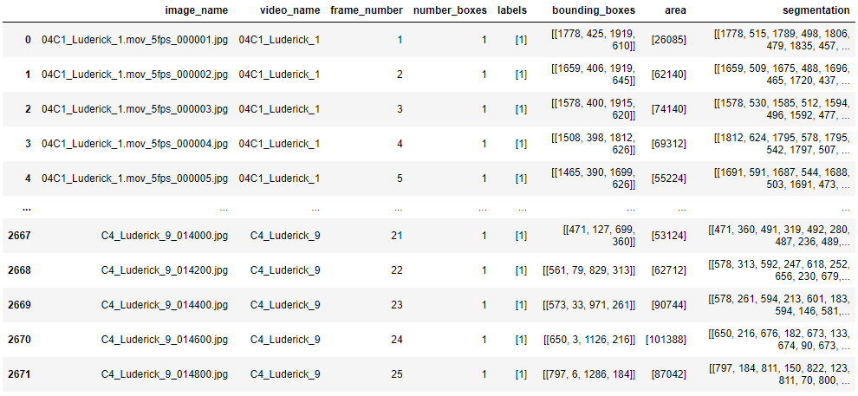

Figure 54: The resulting preprocessed training dataframe. Source: Own

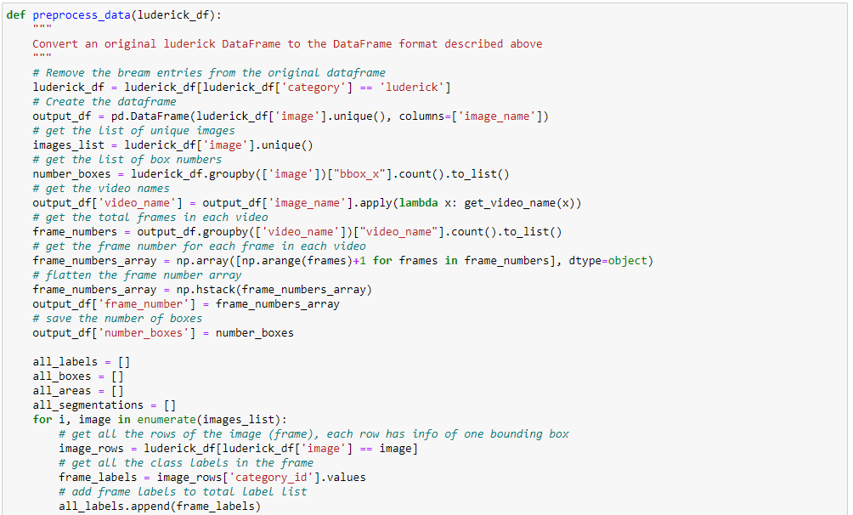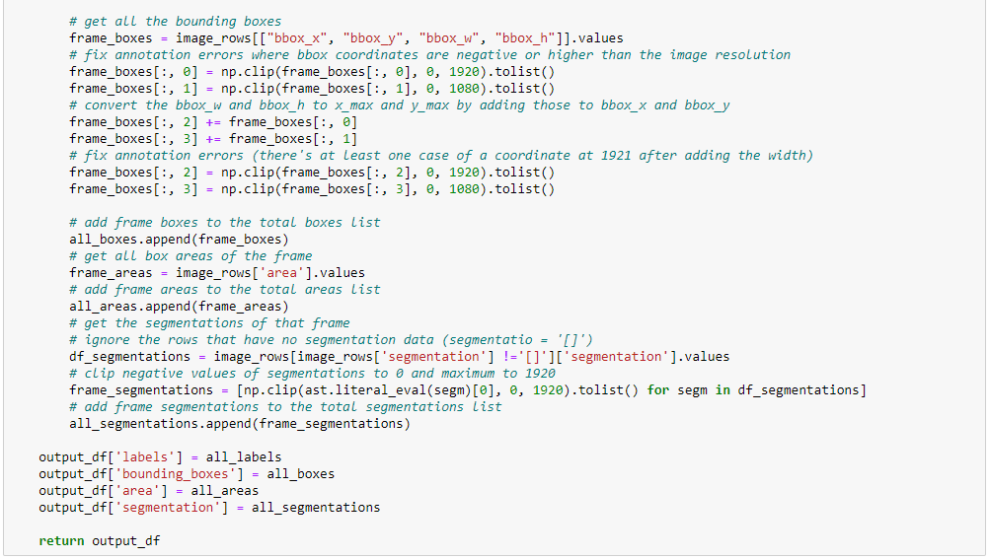

Figure 55: The preprocess_data function, which takes one dataframe in the original annotation structure. Source: Own

After obtaining the preprocessed dataframes for each split, they are saves as CSV files to be loaded and used by other notebooks that carry out training and inference on models.

# 8. Training a Faster R-CNN Model

The first model to try on this project is Faster R-CNN, one of the fastest **two-stage object detection models**. The objective is to retrain this model using **transfer learning** for the Luderick-Seagrass dataset and evaluate it during inference both in terms of speed and accuracy. As mentioned on chapter 4.1, transfer learning is the process of changing the last few layers of a model, usually called the head, with layers fitted for the number of classes of our dataset, while keeping the trainable parameters learned by previous layers, which should be able to generalize image classification and detection problems for new datasets easily.

The two main options considered for training a Faster R-CNN model were the **TensorFlow Object Detection API**, and the **Torchvision** library from **Pytorch**. After experimentation with both options, the Pytorch option was chosen for being more intuitive, robust and customizable than TensorFlow in terms of object detection models.

The Pytorch library offers functions to train deep learning models easily, with a system called **autograd** that offers **automatic differentiation** of functions, needed for the **backpropagation** step of neural networks. The steps to train a neural network on Pytorch are usually the following:

1. Create the custom dataset class.
2. Create data loaders for the dataset to create batches.
3. Create or load the deep learning model.
4. Implement the training and validation loop functions for one epoch.
5. Iterate over each epoch calling the training and validation functions.

The implementation of the Faster R-CNN model training on the Luderick dataset is included in the **Luderick Detection Faster R-CNN - Training** notebook. The notebook starts by loading the training and validation preprocessed luderick dataframes and setting some global variables for training, like the batch size and number of epochs. For training I used 20 epochs for all experiments. I also created some utility functions which save the best model during training and save plots with each iteration loss. Pytorch can take advantage of **Graphic Processor Units (GPU)** from graphic cards for faster training and inference, and the DEVICE variable is set to GPU if available or CPU otherwise and is used to “send” data to that device. Figure 56 shows the global variables used for one of the experiments. I used image resizing on one experiment, which allowed using larger batch sizes as it allowed to keep more images on memory at the same time but discarded it for the last experiment. The CLASSES variable is a list of the classes from the dataset, where the class at position 0 corresponds to the background class, needed for the Faster R-CNN model.

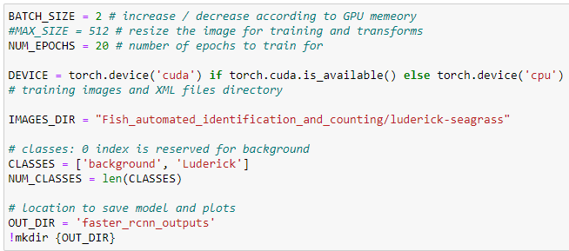

Figure 56: Global variables, including paths to input and outputs directories.

## 8.1 Data Augmentation

It is important to use **data augmentation** on training data to **avoid overfitting**, as mentioned on chapters 4.4 and 6. I created the **get_train_transform** function which transforms images with random flips, 90-degree rotations and blur using the albumentations library, which applies the images transformations to the ground truth bounding boxes, so they are kept in sync. The function also converts the image into the tensor class, which shape is (number of color channels, image height, image width) and is needed for pytorch models. I also create the get_valid_transform, which is used for the validation set and only transforms the image into tensors. Figure 57 shows the code for the training and validation transforms, and Figure 58 displays an image after applying data augmentation.

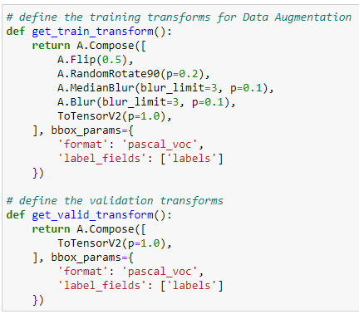

Figure 57: Training a validation transform functions. Source: Own.

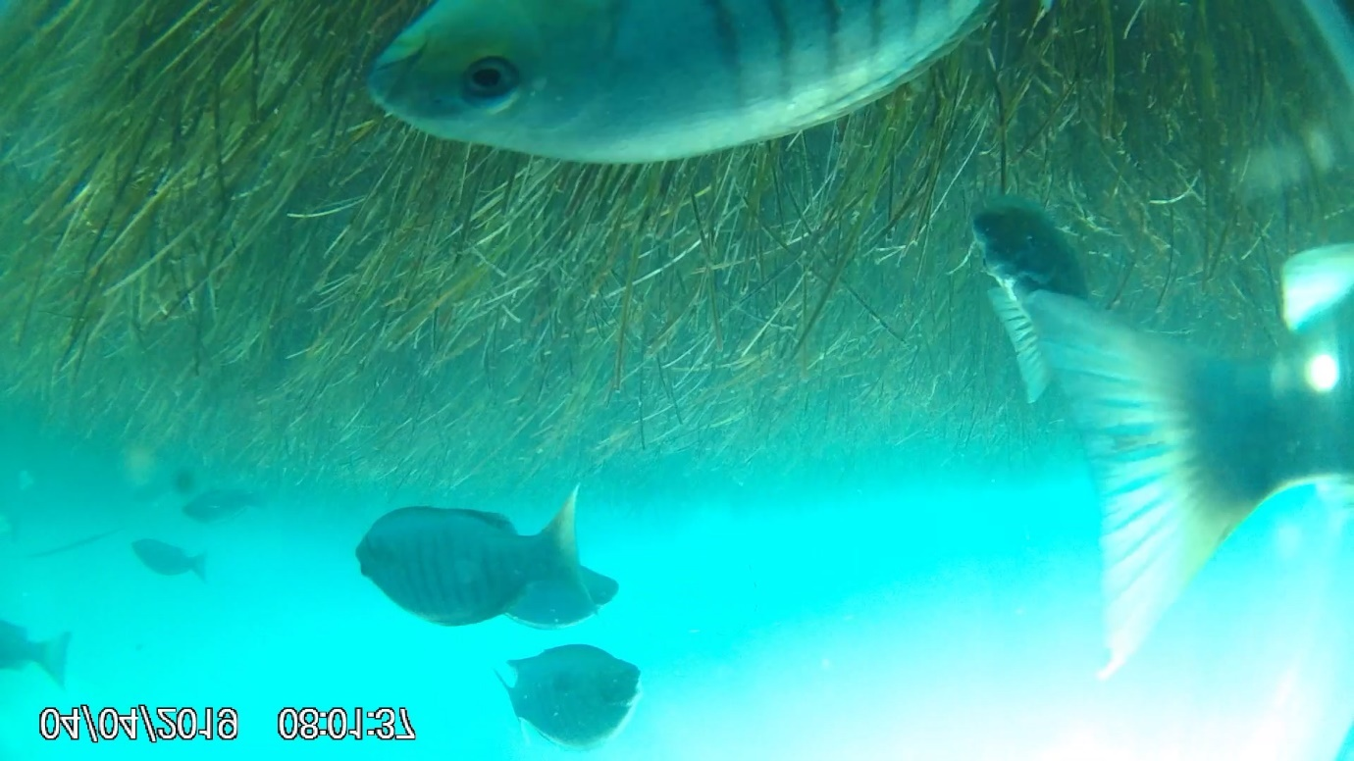

Figure 58: A transformed image with data augmentation. The image has been flipped and rotated 90 degrees. Bounding box coordinates are modified accordingly to the new image. Source: Own.

## 8.2. The Luderick Dataset Class

The next step is the implementation of the luderick dataset class. Dataset classes in pytorch must extend the torch.utils.data.Dataset class and implement the following functions:

* **__init__:** Initializes the dataset with the given parameters
* **__getittem__:** Given a unique id. fetches and returns one item from the dataset with the correct format for training the model.
* **__len__:** Returns the number of items in the dataset, in this case the number of images.

Figure 59 shows the implementation of the **LuderickDataset** class. It is instantiated with a preprocessed luderick dataframe, the relative path to the images and the list of classes, max_size for image resizing and tranforms (like get_train_transform) as input parameters for the **__init__** function.

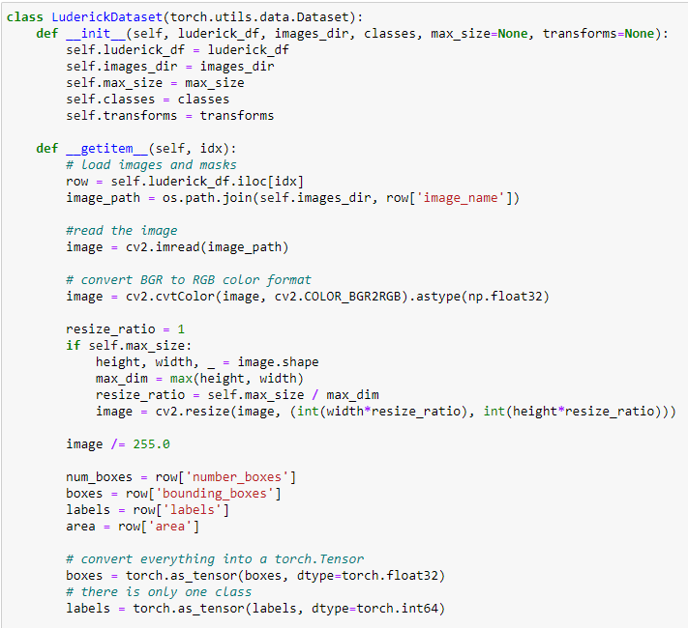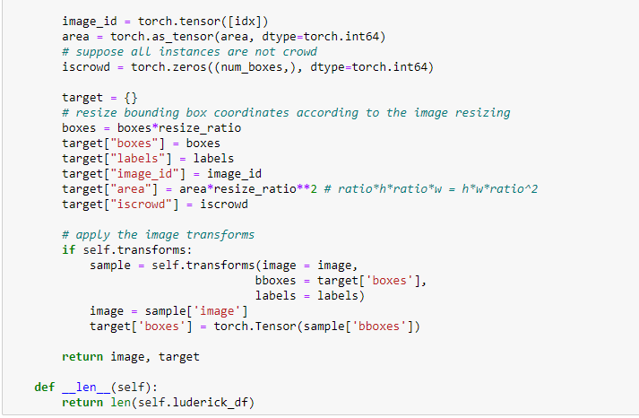

Figure 59: The LuderickDataset class. Source: Own.

The __getitem__ function retrieves an image and its annotation data in the correct format for the Faster R-CNN model implemented by Pytorch. This format should include the image in tensor format and a dictionary, called target, which includes the following keys with values in the tensor format:

* **“boxes”:** A list of bounding box coordinates in the form of [xmin, ymin, xmax, ymax]
* **“labels”:** A list with the class ids of each bounding box.
* **“image_id”:** A unique numerical identifier for the image.
* **“area”:** A list with the area of each bounding box.
* **“iscrowd”** A list of binary values that indicate if there are lots of instances of the same object in the same detection. Some object detection models use this information. It is always set to 0.
* **“masks”** (optional): In the case of using an instance segmentation model such as Mask R-CNN, masks should include a list of binary bitmaps with the same size as the image with values of 1 on the coordinates where there are pixels pertaining to that object and 0 elsewhere. This key is not used for Faster R-CNN.

As the preprocessed dataframe includes a list of boxes with the same format, a list of labels and areas for each image, it is easy to generate the target dictionary. **__getitem__** simply uses the inputted id on the class saved preprocessed luderick dataframe, using the pandas function iloc, which retrieves the ieth row. In the case of using image resizing, a **resize_ratio** is computed as the ratio at which the image has been resized. Bounding box coordinates are multiplied by it to be adjusted to the new size, as well as the areas which are multiplied by the squared value of resize_ratio. The final step in the __getitem__ function is to use the transform functions used for **data augmentation** in the case of the training set, and just converting the image into tensor in the validation set.

The **__len__** function simply returns the number of rows in the preprocessed luderick dataframe.

Figure 60 shows how the LuderickDataset class is instantiated to create the train_dataset and valid_dataset objects.



Figure 60: Creating the dataset objects. Source: Own.

Figure 61 shows an example output of the “target” dictionary with annotation data for the transformed image from Figure 58.

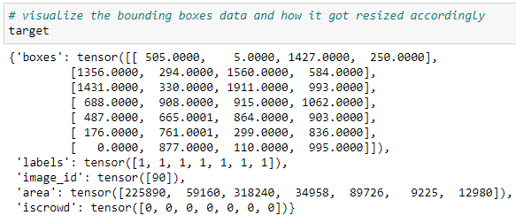

Figure 61: The target dictionary with annotation data from the LuderickDataset class. Source: Own.

## 8.3. Data Loaders

Instances of the **DataLoader** class from pytorch are used for the training and validation datasets, which group data into **batches** with a given **batch size** and can **randomize the data order** with the **shuffle** parameter, which is useful to avoid overfitting on video data, as each sequence would train the model with a list of similar images if they were fed by order. Figure 61 shows the code for the train and validation dataset loaders.

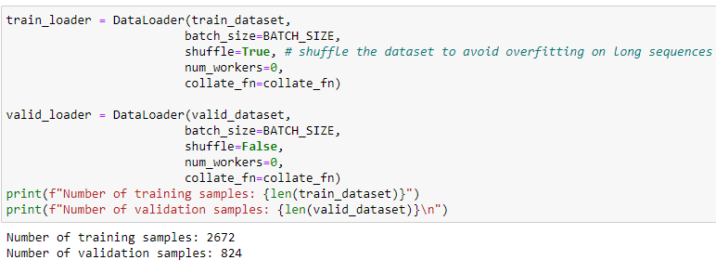

Figure 62: Train and validation data loaders. Source: Own.

## 8.4. Creating the Model

Pytorch offers an implementation of the Faster R-CNN model which can be loaded from the library with pretrained weights on the COCO dataset. As explained in chapter 3.3, Faster R-CNN consists of an **RPN** that generates **ROIs** and a **Fast R-CNN detection** **head** that uses those ROIs for a final bounding box regression and object classification. The loaded model from pytorch has the **Resnet50-FPN backbone**, which is the default for Faster R-CNN since Mask R-CNN. To apply **transfer learning,** the Fast R-CNN head is replaced with a new instance with a different number of classes, 2 in the case of the luderick dataset, including the background and luderick classes. Figure 63 shows the create_model function, which returns an instance of the Faster R-CNN model with a Fast R-CNN detection head that predicts the given number of classes.

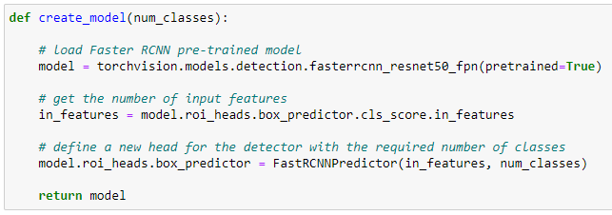

Figure 63: The create_model function returns an instance of the Faster R-CNN model. Source: Own.

## 8.5. The Training and Validation Functions

The model is to be trained for **20 epochs**. One epoch means that all the images from the training dataset have been fed to the model once. To train the model for one epoch, I created the train function, which iterates over the training dataset batch by batch using the train data loader, which returns one batch from the dataset at each iteration, until all batches have been used. I use the tqdm library to iterate over batches, which creates a visual representation of a progress bar updating in real time while the process is running.

The pytorch **automatic differentiation (autograd)** records the partial derivatives of all the trainable parameters for each function they go through, including convolution layers, activation functions and loss functions. By using the model with a batch as input, those partial derivatives can be used to update weights using an **optimizer**, like **Stochastic Gradient Descent (SGD)**, with a learning rate and momentum, which adjust the speed at which the weights are updated, and weight decay, which is a **regularization** method that adds a penalty to weight values, resulting in smaller weights.

In one iteration of the **train function**, images and target dictionaries are loaded from **one batch**, and used as input to the Faster R-CNN. Pytorch models can be used in training or inference mode, when used on training mode they return the loss value obtained from the predictions. The Faster R-CNN model returns the losses for the batch inputs, **including objectness and anchor box regression losses from the RPN**, and the **final detection boxes regression and object classification losses** from the Fast R-CNN head. After retrieving those losses, the train function adds them to a single total loss value, which is used by **autograd** by calling the **backward** function on the total loss variable to compute the partial derivatives of the weights and using the **step** function from the **optimizer** to update the weights. For each new batch at the start of each iteration, partial derivatives are resetted by calling the **zero_grad** function from the optimizer as one **batch should not affect the next**. The loss from each iteration is saved into a global variable for plotting. Figure 64 shows the implementation of the train function.

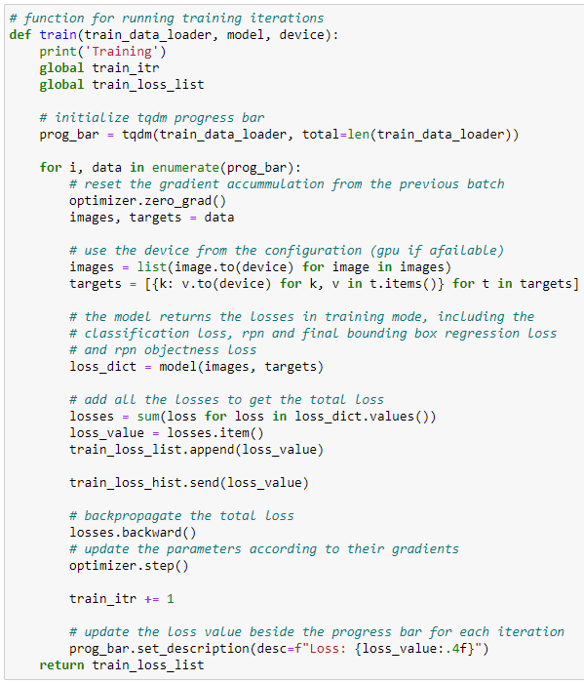

Figure 64: The train function, which trains the model for one epoch. Source: Own.

ds

Em comentaves que se't faria difícil emplenar moltes més pàgines, però el cas és que el que falta per documentar és bastant important. D'una banda, evidentment, els resultats. Hauràs de descriure les implementacions que has fet, les mètriques emprades i els resultats que has obtingut. La major part d'aquesta feina ja la tens feta als quaderns Jupyter, així que quasi serà una tasca de passar-ho al document i afegir una mica d'explicació textual.  
  
D'altra banda, hauries de posar una introducció que motivés la feina feta. El tema en si és bastant inusual (detecció de peixos) així que n'has de parlar i ho has de motivar. És a dir, no has fet el "típic" (detecció de cares, de persones, ...) sino que t'has centrat en peixos i compares distintes tècniques en aquest entorn concret. Això ho has d'explicar i motivar als capítols introductoris.  
  
Et deixo aquí els comentaris sobre el document que m'has adjuntat. Com et deia, són majoritàriament formals i imagino que molts d'ells ja els tens en compte:  
  
  
* Figures, taules, ... han de tenir peu de figura/taula (Figure x: An example of ... o Table y: Obtained accuracies of ...) i han d'estar referenciades dins del text (... as it can be observed in Figure x o ... the results are summarized in Table y). No pot haver-hi figures ni taules que no estiguin referenciades (ni tampoc pots escriure "The following table/figure/...", sino "Figure x shows...").  
  
  
* A la pàgina 2 dius "the values of each of the nxn values in each kernel and the biasses are the trainable weights...". A part de l'errada "the values of ... values", abans no has dit que eren els biasses. Podries, a la pàgina anterior, just abans de "Each kernel is passed through..." posar quelcom de l'estil "Another value, called bias, is added to the result of such dot product". De fet, això ho dius més endavant també, però és convenient que també ho diguis aquí. I, a més, potser no diria "are the trainable weights" sino "trainable parameters", però no és gaire rellevant.  
  
  
  
  
  
* A totes les imatges/figures que no siguin teves has d'indicar d'on són. Pots posar al peu de figura quelcom de l'estil "Figure xxx: bla bla bla. Source: [25]" (si tens una referència bibliogràfica) o bé "Source: http://..." si és un web o similar.  
  
Salutacions,

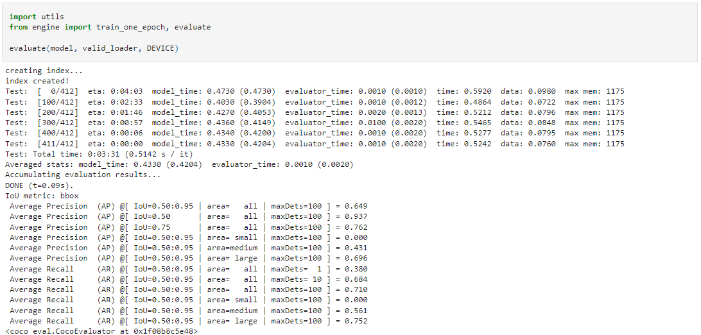

Faster RCNN mean fps results

My pc = 7.53 fps with fast model (min_size=512). 132 ms inference time

Idiada pc = 14.5 fps with fast model (min_size=512)

Mask RCNN mean fps results

My pc = 7.14 fps with fast model (min_size=512)

Idiada pc = 3.145 fps with fast model (min_size=512)

YOLOv5 video results

YOLOv5m (medium)

My pc = 33.7 fps

Glossary

**Bounding Box**: A rectangle in an image that contains a detected object.

**CNN**: Convolutional Neural Network, a neural network with convolutional layers.

**Feature Map**: The two or three-dimensional output of a layer in a neural network.

**FPN**: Feature Pyramid Network, a neural network with bottom-up and bottom-down feature map pyramids with lateral connections

**FPS**: Frames Per Second, the number of frames included in a single second of a video or the number of images a model can apply inference to in a single second.

**IoU**: Intersection over Union

**mAP or AP**: mean Average Precision, an evaluation method for object detection models that computes the area under the precision-recall curve.

**NMS**: Non-Max Supression, filtering out bounding boxes with lower IOU with the same ground truth box.

**R-CNN**: Region based CNN, a two-stage object detection model that uses CNN and ROIs

**ROI**: Region of Interest, a rectangle fragment from an image where there are potential objects.

**RPN**: Region Proposal Network, a neural network that predicts ROIs

**YOLO**: You Only Look Once, a one stage object detection model that only processes an image once.

Other Object Detection architectures:

Cascade R-CNN

Single shot Detection

Feature Pyramid Networks

EfficientDet

RetinaNet

2 Stage

Sliding window

Selective Search

RCNN

Faster RCNN

Mask RCNN

1 Stage

YOLO

Transformer? SWIN

Sources:

CNN Explainer website.

R-CNN paper: <https://arxiv.org/pdf/1311.2524.pdf>

Fast R-CNN paper: <https://arxiv.org/pdf/1504.08083.pdf>

Faster R-CNN paper: <https://arxiv.org/pdf/1506.01497.pdf>

Faster R-CNN analysis <https://towardsdatascience.com/faster-r-cnn-for-object-detection-a-technical-summary-474c5b857b46>

Mask R-CNN paper: <https://arxiv.org/pdf/1703.06870.pdf>

Feature Pyramid Networks (FPN) paper <https://arxiv.org/pdf/1612.03144.pdf>

YOLO paper: <https://arxiv.org/pdf/1506.02640.pdf>

YOLOv2 paper: <https://arxiv.org/pdf/1612.08242v1.pdf>

YOLOv3 paper: <https://arxiv.org/pdf/1804.02767.pdf>

YOLOv4 paper: <https://arxiv.org/pdf/2004.10934.pdf>

CIoU Loss paper: <https://arxiv.org/pdf/1911.08287.pdf>

YOLOv4 architecture images: <https://github.com/AlexeyAB/darknet/issues/5891#issuecomment-695117608>

CSPnet paper: <https://arxiv.org/pdf/1911.11929.pdf>

YOLOv5 v5.0 architecture images: <https://blog.csdn.net/Q1u1NG/article/details/107511465>

YOLOv5 6.0 architecture and other details: <https://github.com/ultralytics/yolov5/issues/6998>

SSD paper: <https://arxiv.org/pdf/1512.02325.pdf>

RetinaNet paper: <https://arxiv.org/pdf/1708.02002.pdf>

Barrier reef Kaggle: <https://www.kaggle.com/c/tensorflow-great-barrier-reef>

FishCLEF dataset: <https://github.com/perceivelab/FishCLEF-2015>

Performance Analysis: YoloV5 vs YoloR: <https://towardsai.net/p/l/performance-analysis-yolov5-vs-yolor>

Comparing YOLOv3, YOLOv4 and YOLOv5 for Autonomous Landing Spot Detection in Faulty UAVs: <https://www.mdpi.com/1424-8220/22/2/464>

YOLOv5 focus layer: <https://github.com/ultralytics/yolov5/discussions/3181m1>

Non-max supression: <https://towardsdatascience.com/intuition-and-implementation-of-non-max-suppression-algorithm-in-object-detection-d68ba938b630>

<https://towardsdatascience.com/r-cnn-fast-r-cnn-faster-r-cnn-yolo-object-detection-algorithms-36d53571365e>

YOLOV4 Research review <https://www.thinkautonomous.ai/blog/?p=introduction-to-yolov4-research-review>

<https://towardsdatascience.com/object-detection-with-convolutional-neural-networks-c9d729eedc18>

mean average precision mAP

<https://www.youtube.com/watch?v=FppOzcDvaDI>

<https://kharshit.github.io/blog/2019/09/20/evaluation-metrics-for-object-detection-and-segmentation>

Roi Pooling

<https://deepsense.ai/region-of-interest-pooling-explained/>

Mean Average Precision:

<https://blog.paperspace.com/mean-average-precision/amp/>

Guias para usar Faster RCNN y Mask RCNN con pytorch:

<https://pytorch.org/tutorials/intermediate/torchvision_tutorial.html>

<https://debuggercafe.com/faster-rcnn-object-detection-with-pytorch/>

<https://debuggercafe.com/custom-object-detection-using-pytorch-faster-rcnn/>

<https://debuggercafe.com/a-simple-pipeline-to-train-pytorch-faster-rcnn-object-detection-model/>